14. Dyke Design

14.1 Past studies
Various configurations have been proposed since the conceptualisation of the dyke. An extract of the previous studies carried out for determination of configuration is briefed below:

14.1.1 Royal Haskoning Pre-feasibility Report (1998):
Royal Haskoning carried out feasibility study for the Kalpasar project in 1998. The dyke was envisaged to have two headlands on either side of gulf with caisson incorporated into the dam body. The description of the sections presented by Royal Haskoning report is presented below.
The dyke body of the headlands on either side of the Gulf comprises of two rock fill toes inner slopes of 1:2 and outer slopes of 1:3. The outer dyke slope has a slope of 1:5 above the mean sea level to reduce wave run up. On the basin side of the dyke a berm of 35 m was conceived to accommodate a road. The outer dyke slope is protected against wave attack by a geotextile and a double layer of rock up to a level of GTS +9m. The outer dyke above a level of GTS + 9m as well as the inner dyke slope from the berm upwards are protected against wave attack and erosion by a layer of asphalt. The embankment core comprises of sand. A geotextile in between the embankment and the rock fill toes keeps the sand from washing out. The bottom protection consists of a geotextile covered with 0.5 m of rock in the shallow areas or block mats covered by a layer of 1.0 m rockfill in the deep areas (depths larger than 10 m). The dyke body of the closure gap resembles the dyke body of the headlands. The bottom protection consists of a mattress with a thickness of 1.0 m.
The caissons envisaged will be 108 m long, 36 m wide and 30 m heigh. The caissons will have six discharge openings each with a width of approximately 18 m. The caissons will be constructed in the dry in construction pits located on either side of the Khambhat Gulf Closure dyke. The construction pits will be flooded after finalization of the construction of the caissons. The caissons will then be floated to their proper location and sunk on the sills already constructed by controlled placement. The caissons will be in place during closure of the rockfill closure gap.
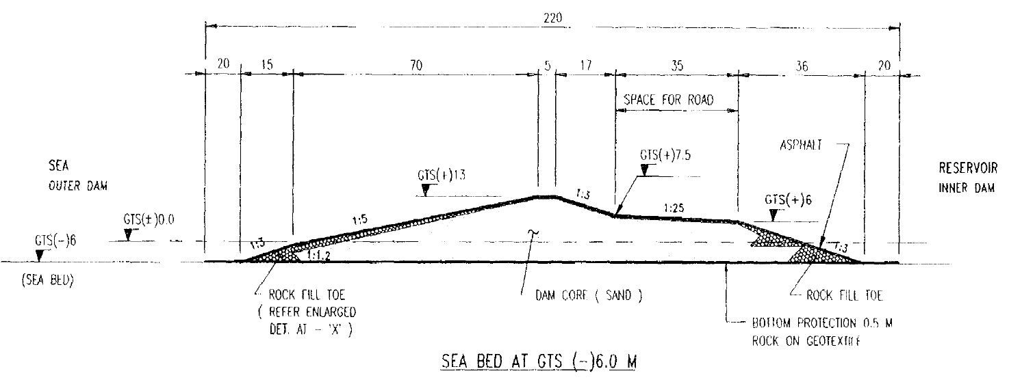
Fig.1 Cross section of Headlands (Intertidal region) by Royal Haskoning

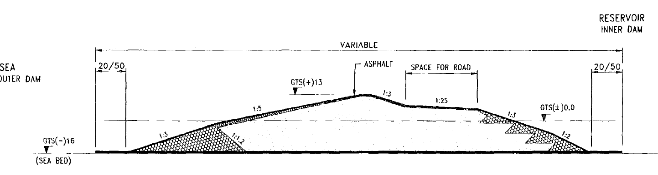
Fig.2 Representative Cross section of dyke in Gulf Region without caissons by Royal Haskoning
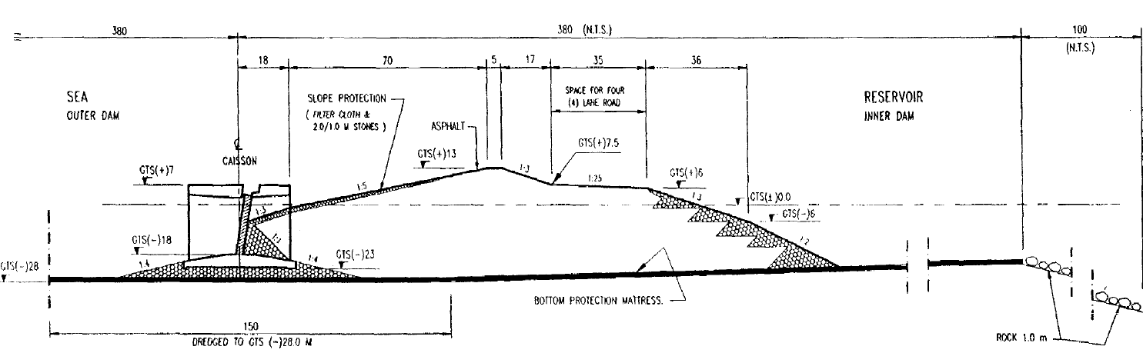
Fig.3 Representative Cross section of dyke in Gulf Region with caissons incorporated into dyke by Royal Haskoning
The tidal currents will be able to flow freely through the open caissons throughout the execution of the rockfill closure. All caissons are closed simultaneously by means of lowering large gates in the discharge openings after finalization of the construction of the rockfill closure. The caissons are incorporated in the dyke body after closure is completed. The different sections described are presented as Figures in Fig XXX, Fig. XXX and Fig. XXX.

14.1.2 Ethics Advisory Group, Kalpasar
Based on the previous studies and preliminary studies carried out for the new alignment, taking into consideration the minimal overtopping required and the ability of the dyke to withstand extreme natural events, the section was further revised with an addition of Floor Regulator structure to drain off excess water due to flooding on the reservoir side. A representative cross-section of -5m and -30m MSL sections are indicated in Fig.4 and Figure 5.
The -30m cross-section is explained as an indicative of the structure proposed. The section consists of an embankment fill on the reservoir side and a rock fill on the seaside. The seaside has a slope of 1:2 while that of embankment is 1:2.5. The top level is fixed at +14.5m MSL with a crest slab 18m wide on top. Seaside consists of rock core with three different armour layers that decrease in size from top to the bottom of the dyke. Xbloc had been considered as armour units in the design. The weight of the armour units is 48t, 12t and 8t, respectively. There are two additional berms provided on the seaside for additional stability. The underlayer consists of 5t, 2t and 0.7t rocks with the thickness as 2.4m, 1.8m and 1.3m. A riprap is provided on the embankment side to hold the embankment in place over which a 80m wide transportation corridor was proposed.

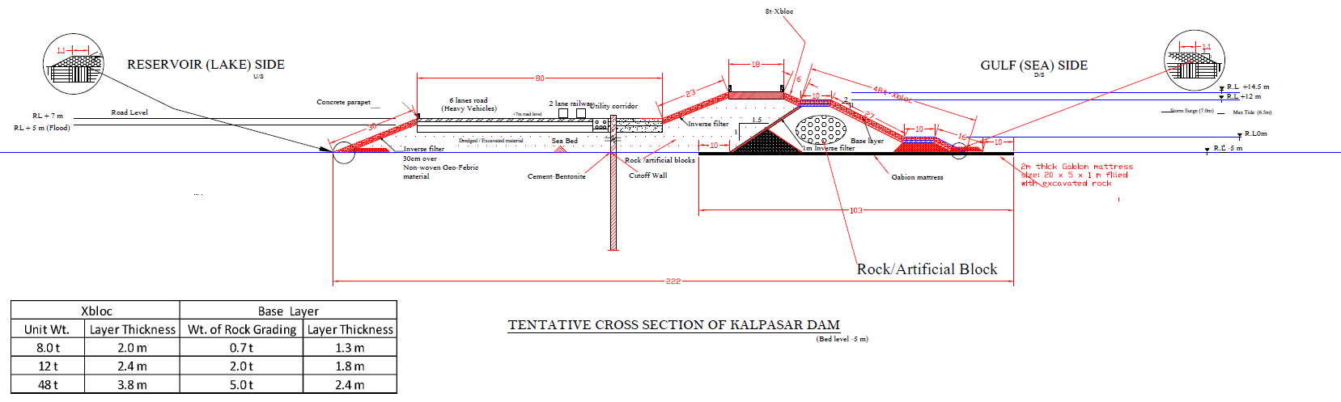
Figure.4 Cross Section of the dyke at -5m MSL as per EAG
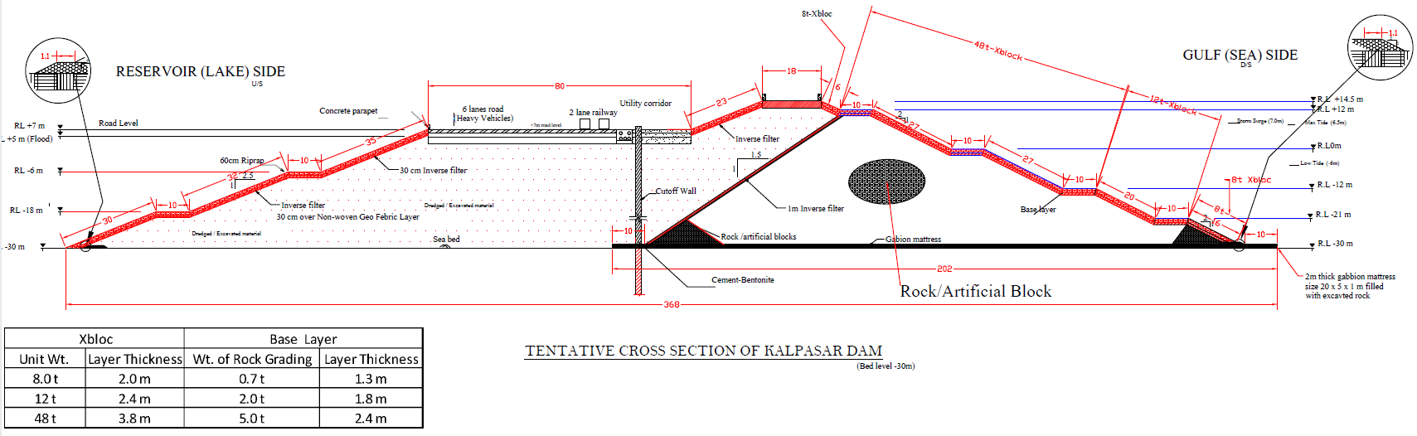
Figure.5 Cross Section of the dyke at -30m MSL as per EAG

14.2 Geotechnical Design

14.2.1 Loads
The loads acting on the dyke are classified as 1. Dead load 2. Water load 3. Imposed load and 4. Earthquake load.
(a) Dead Load
Dead load is the weight of the dyke due to gravity and can be calculated by the unit weights of various components. The approximate values of loading intensity exerted on the subsoil due to the self-weight of both breakwater and embankment for various seabed levels are shown in Table 15.1.
Table 15.1 Loading intensity for static loading for different heights of the Dyke
Loading intensity (kPa)
Height of the Dyke (m) | Below breakwater | Below embankment
7.5 | 150 | 80
16 | 320 | 180
24 | 480 | 280
29 | 580 | 380
34 | 680 | 480
39 | 780 | 580
44 | 880 | 680
49 | 980 | 780
(b) Water Load
Based on the expert committee the water levels and tidal ranges are considered for the post-construction of the dyke scenario. Hence in the present analysis, High astronomical tide level (+6.2 m w.r.t MSL) and Lowest Low Water Line (-5.3 m w.r.t. MSL) on the seaside and Maximum water level (+5m w.r.t. MSL) and Full reservoir level (+3 m w.r.t MSL) are considered on the reservoir side for the application of hydrostatic loading on the dyke structure. The design water levels adopted for the design is given below.
Full Reservoir level (FRL) | = | EL (+) 3.0 | m
High Flood level (HFL) | = | EL (+) 5.0 | m
Lowest Low Tide Level (LLTL) | = | EL (-) 5.3 | m
Highest High Tide Level (HHTL) | = | EL (+) 6.2 | m
Storm Surge | = | EL (+) 8.1 | m

(c) Imposed load
The location of loading on the top of pavement from different imposed loads is considered based on the studies related to traffic assessment provided. The calculation of loading intensity from these vehicles over the pavement top is computed as per IRC6: 2014.
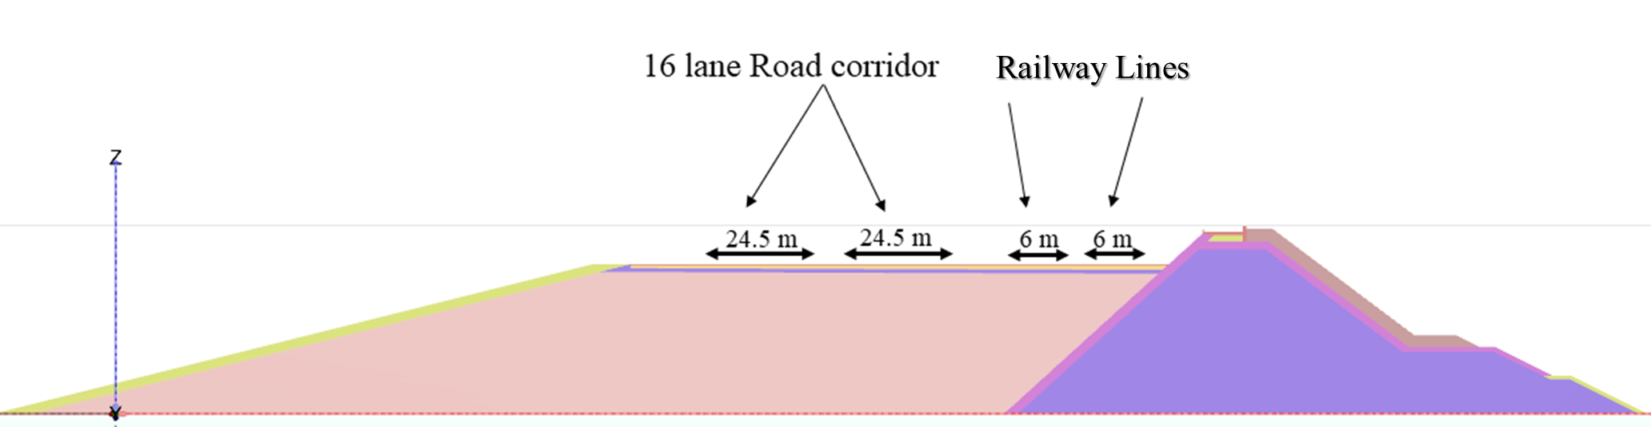
Figure 15.6 Cross section showing Road and Rail corridor

(d) Earthquake Load (Equivalent Static and Dynamic)
The seismic settlement analysis is carried out by applying an acceleration time history at the base of the dyke. The site-specific seismic studies carried out by NGRI reported a peak ground acceleration of 0.36g and 0.225g considering the return period of 975 and 250 years, respectively. Hence, the acceleration time histories corresponding to the PGAs are considered for present analyses, as shown in Figure 15.7. Also, equivalent static loads corresponding to the PGAs of 0.225g and 0.36g are considered for stability analysis.
a)
b)
Figure 15.7 Acceleration time histories having PGA a)0.225g b)0.36g
14.2.2 Analysis
(a) Modelling and Software
In this section, modelling is simply classified into three categories: 1. Geometrical modelling 2. Numerical modelling 3. Constitutive modelling
1. Geometrical modelling
Based on the stability analyses, a slope of 1:4 is adopted on the reservoir side for the sand fill (Figure 15.8). The dredged material used as the base for the entire stretch for the heavy vehicles and trains was replaced with 1 m thick rock fill at the base of the pavement (Figure 15.8). A slope of 1:1.1 is adopted for the rockfill towards the reservoir side to optimise the material quantity required. Analysis for all the cross sections of the dyke is carried out based on the design cross section shown in Figure 15.8 and the results of the analysis are discussed in detail in the section pertaining to results and discussions.
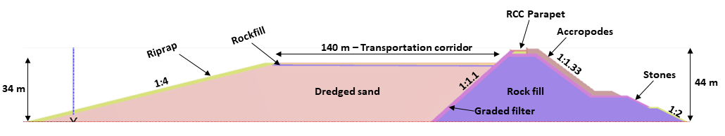
Figure 15.8 Final cross section of the dyke
2. Numerical modelling
The numerical modelling was carried out using a Finite Element tool to study the stability, strength, seepage and settlement. The model study have been carried out with PLAXIS 2D with relevant modules. The module corresponding to various studies and relevant boundary conditions has been tabulated in Table 15.3 Mesh and boundary convergence study was carried out. Global coarseness is used to define the element size of the mesh based on the model dimensions. To avoid inaccuracy due to poor quality mesh, size of an element is reduced in the areas where 1. stress concentrations are expected to be more 2. Elements with sharp angles, as shown in Figure 15.9. The boundary condition was placed far away from areas of interest.
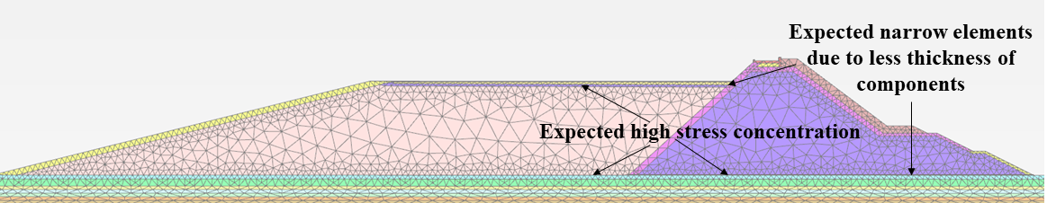
Figure 15.9 Cross section showing mesh coarseness at different locations

Table 15.3: Boundary conditions for different methods of analyses
Stability
Boundary | x_{min} | x_{max} | y_{min} | y_{max}
Deformations | Normally fixed | Normally fixed | Fully fixed | Free
Ground water flow | Open | Open | Closed | Open
Settlement
Deformations | Normally fixed | Normally fixed | Fully fixed | Free
Ground water flow | Open | Open | Closed | Open
Seepage
Ground water flow | Open | Open | Closed | Open
Dynamic
Deformation | Normally fixed | Normally fixed | Fully fixed | Free
Dynamics | Free – Field | Free – Field | Compliant base | None
Ground water flow | Open | Open | Closed | Open

3. Constitutive modelling
The PLAXIS utilises various material model to model the soil behaviour. The modelling for Kalpasar project utilises two material models as explained below.
Linear Elastic:
It is based on Hooke's law of isotropic elasticity, which requires two parameters [E, µ]. It is generally preferred to model the stiff soil, concrete, and rock because the applied stresses are well within the linear regime. In this study, the components such as ACCROPODE II and RCC are modelled using the linear elastic constitutive model.
Mohr-coulomb:
Mohr-coulomb model is considered for material modelling as it requires five parameters [E, µ, c, ϕ, ψ, σt] which are very familiar and can be derived from basic tests on soil. It consists of linear elastic perfectly plastic parts in which the first part is based on Hooke's law and the second one is based on Mohr-coulomb criteria.
(b) Stability
1. Static
The Safety calculation type is an option available in PLAXIS 3D to compute global safety factors. In the safety approach, the shear strength parameters are successively reduced until failure of the structure occurs. Stability analyses are carried out for all the cross sections of the dyke in both the gulf and intertidal region, considering all the loading conditions.

2. Equivalent Static
Equivalent static analysis is a simplified way of approximating earthquake induced loads as equivalent body forces. The existing force in each element of the mesh is added by the inertial force, which is proportional to the input acceleration coefficients. This equivalent static force is applied to all the elements of the mesh, and hence large shear stresses develop at the boundaries.
(c) Strength
In all the analyses, deviatoric stresses in the top layer of the subsoil are recorded for various loading conditions and compared with the bearing capacity values of the top foundation soil.
(d) Settlement
The total settlement is divided into three categories, i.e. 1. Construction settlement 2. Settlement due to imposed load 3. Settlement due to Earthquake loading. In the first case, each cross section is divided into layers of 5 m, and settlement is calculated at each phase of construction. Secondly, Imposed loads are considered to calculate the compression within the embankment. Thirdly, Earthquake acceleration time histories are considered below the base of the Dyke to calculate the permanent displacements (horizontal and vertical).
(e) Seepage
The seepage quantity is calculated from a steady state flow analysis with MSL on the sea side and varying water levels on the reservoir side, as shown in Figure 15.11. The quantity of seepage is obtained at the location of the reservoir slope, as shown in Figure 15.10.

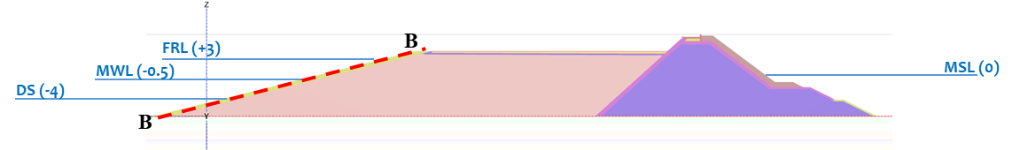
Figure 15.10 The location in the reservoir slope where the quantity of seepage is computed: Section B-B
Figure 15.11 Variation of reservoir water level w.r.t MSL in year

The plastic stress-strain analysis, stability/safety, strength, and dynamic and seepage analyses are carried out for eight different cross sections of the dyke in the gulf and intertidal region. The dyke sections are 7 m, 16.5 m, 24 m, 29 m, 34 m, 39 m, 44 m, and 49 m high, and the corresponding reduced levels of the sea bed are +5 m, 0 m, -5 m, -10 m, -15 m, -20 m, -25 m, and -30 m. An initial analysis considering the gravity load and steady state seepage condition is carried out. During the initial phase, the soil stratum is activated along with water of RL +8.1 m (Design water level on the sea side). Secondly, a plastic stress-strain analysis is carried out for the dyke to compute the displacements. The dyke is constructed in stages of 5 m and the displacements happening at every stage of construction and factor of safety values are discussed in detail. Thirdly, plastic stress-strain analysis is carried out by activating the live load of the vehicles to calculate compression within the embankment. In the fourth stage, a safety analysis is carried out considering the hydraulic conditions as in the previous stage, by strength reduction method. Then a coupled flow analysis is carried out by considering MSL on the seaside to estimate the seepage quantity. In the next stage, an equivalent-static analysis is carried out to determine the factor of safety under seismic conditions. Finally, a dynamic analysis is performed by applying an acceleration time history at the base of the model to determine the seismic settlement. In this chapter, all the analyses based on borehole data (GT/SPT 2 and GT/SPT 7) are discussed in each section and the results for all the borehole data GT/SPT2 and GT/SPT7 are shown in corresponding summary subsections.
The improved subsoil parameters for the top 6 m shown in Table 15.13 are considered in all the present analyses for the gulf region, and parameters in Table 15.15 are considered for the intertidal zone. The geotechnical properties of the different dyke elements and the material model used for various elements are presented in Table 15.5 and Table 15.6. As the material properties and flow parameters are not available for the dyke, the values are assumed based on the multidisciplinary project report on breakwater engineering by Delft University of Technology, 2015, Durban Dig-Out Port Research.

Table 15.5 Material parameters of the dyke elements used in FE modelling
Parameter | Dredged sand | Gabion mat | ACCROPODE II
Material model | Mohr-Coulomb |  | Linear Elastic
Drainage type | Drained
Unsaturated unit weight, $γ_{unsat}$ (kN/m³) | 16 | 18 | 20
Saturated unit weight,$γ_{sat}$ (kN/m³) | 20 | 21 | 20
Elastic Modulus, $E$ (MPa) | 32 | 1000 | 100
Poisson ratio, $ν$ | 0.33 | 0.2 | 0.2
Cohesion, $c$ (kN/m²) | 1 | 1
Angle of internal friction, $ϕ$ (degrees) | 35 | 45
Dilatancy Angle $ψ$ (degrees) | 0 | 15
Permeability coefficient,  $K_{x}=K_{y}=K_{z}$ (m/day) | 13 | 86 x 10³ | 86 x 10³

Table 15.6 Material parameters of various stones used in FE modelling
Parameter | 10-500 kg | 300-500 kg | 500-1000 kg | 2-4 T | 8-10 T | Riprap
Material model | Mohr-Coulomb
Drainage Type | Drained
Unsaturated unit weight, $γ_{unsat}$ (kN/m³) | 18 | 18 | 18 | 18 | 18 | 18
Saturated unit weight,$γ_{sat}$ (kN/m³) | 21 | 21 | 21 | 21 | 21 | 21
Elastic Modulus, $E$ (MPa) | 1000 | 1000 | 1000 | 1000 | 1000 | 1000
Poisson Ratio, $ν$ | 0.2 | 0.2 | 0.2 | 0.2 | 0.2 | 0.2
Cohesion, $c$ (kN/m²) | 1 | 1 | 1 | 1 | 1 | 1
Angle of internal friction, $ϕ$ (degrees) | 45 | 45 | 45 | 45 | 45 | 45
Dilatancy Angle $ψ$ (degrees) | 15 | 15 | 15 | 15 | 15 | 15
Permeability coefficient,  $K_{x}=K_{y}=K_{z}$ (m/day) | 43 x 10³ | 70 x 10³ | 70 x 10³ | 86 x 10³ | 86 x 10³ | 43 x 10³

14.2.3 Stability Design
a) Static
The stability analysis is carried out for all cross sections in the gulf region and intertidal zone considering three loading conditions 1. End of breakwater construction 2. End of embankment construction 3. Live loads. Details about the location of the failure pattern of slopes and the factor of safety values are discussed in this section.
(1) Gulf region
Dyke is constructed in stages of 5 m, initially starting with the breakwater on the seaside, followed by the embankment on the reservoir side and stability analysis is carried out for each phase of construction. It can be seen from the Table 15.7 that the factor of safety value reduces during the construction of the breakwater till crest level and again increases after the complete construction of both breakwater and embankment. There is no trend in the factor of safety values at the end of cross sections because of the provision of berms on the seaside slope for deeper seabed level cross sections.
Table 15.7 Factor of safety values during staged construction for various cross sections
Breakwater
Stages | Height of the Dyke
Stages | 49 m | 44 m | 39 m | 34 m | 29 m | 24 m
Stage 1 – 4 m | 1.7 | 1.7 | 1.8 | 1.7 | 1.7 | 1.6
Stage 2 – 9m | 1.4 | 1.4 | 1.4 | 1.4 | 1.4 | 1.4
Stage 3 – 24 m | 1.3 | 1.3 | 1.3 | 1.3 | 1.3 | 1.3
Stage 4 – 29 m | 1.2 | 1.3 | 1.2 | 1.2 | 1.3 | *
Stage 5 - 34 m | 1.2 | 1.2 | 1.2 | 1.2 | * | *
Stage 6 - 39 m | 1.2 | 1.2 | 1.2 | * | * | *
Stage 7 – 44 m | 1.2 | 1.2 | * | * | * | *
Stage 8 - 49 m | 1.2 | *
Breakwater + Embankment
Stage 9 – 4 m | 1.2 | 1.2 | 1.2 | 1.2 | 1.3 | 1.4
Stage 10 – 9 m | 1.2 | 1.2 | 1.2 | 1.3 | 1.4 | 1.9
Stage 11 – 14 m | 1.2 | 1.2 | 1.2 | 1.5 | 1.9 | 1.9
Stage 12 – 19 m | 1.2 | 1.2 | 1.3 | 1.8 | 1.9 | *
Stage 13 - 24 m | 1.3 | 1.3 | 1.4 | 1.8 | * | *
Stage 14 - 29 m | 1.4 | 1.4 | 1.8 | * | * | *
Stage 15 – 34 m | 1.7 | 1.7 | * | * | * | *
Stage 16 – 39 m | 2 | *
* End of construction
Figure 15.12 shows the incremental displacement and failure pattern for the dyke of all cross sections at the gulf region at the end of breakwater construction. It can be seen that the plastic strains developed along the reservoir side of the breakwater slope during strength reduction technique. But, the displacements for different cross sections are not comparable in strength reduction technique.
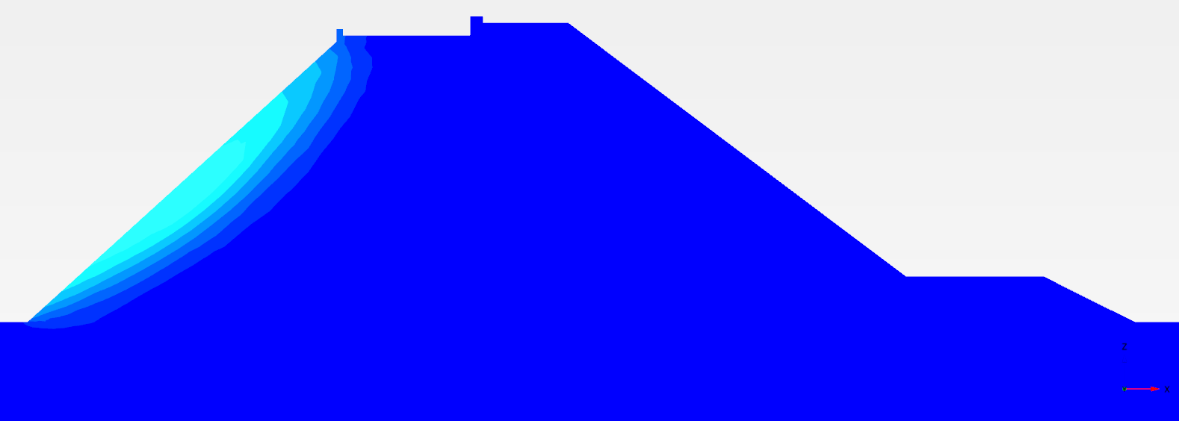 | 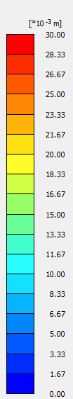
(a)
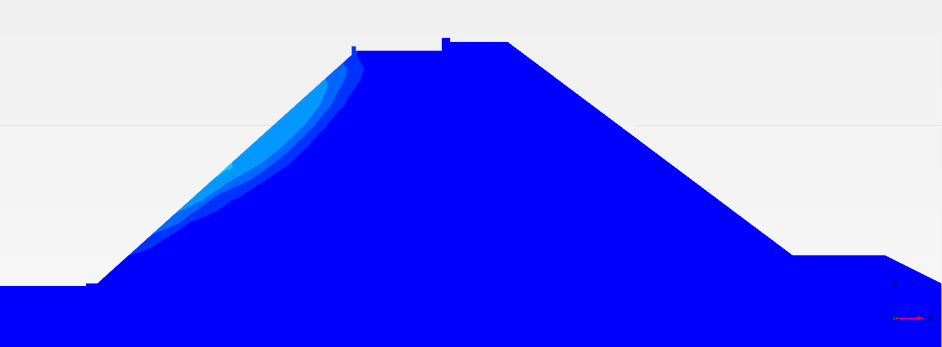
(b)
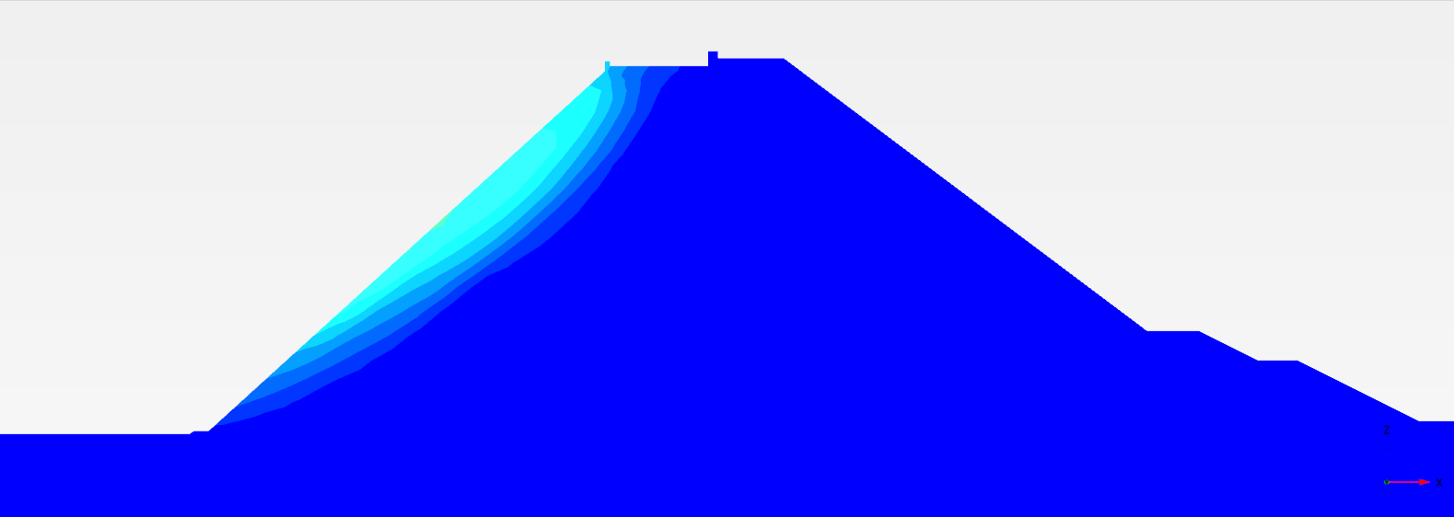
(c)
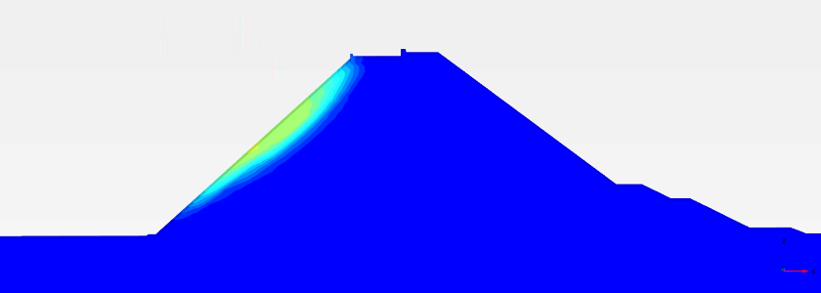
(d)
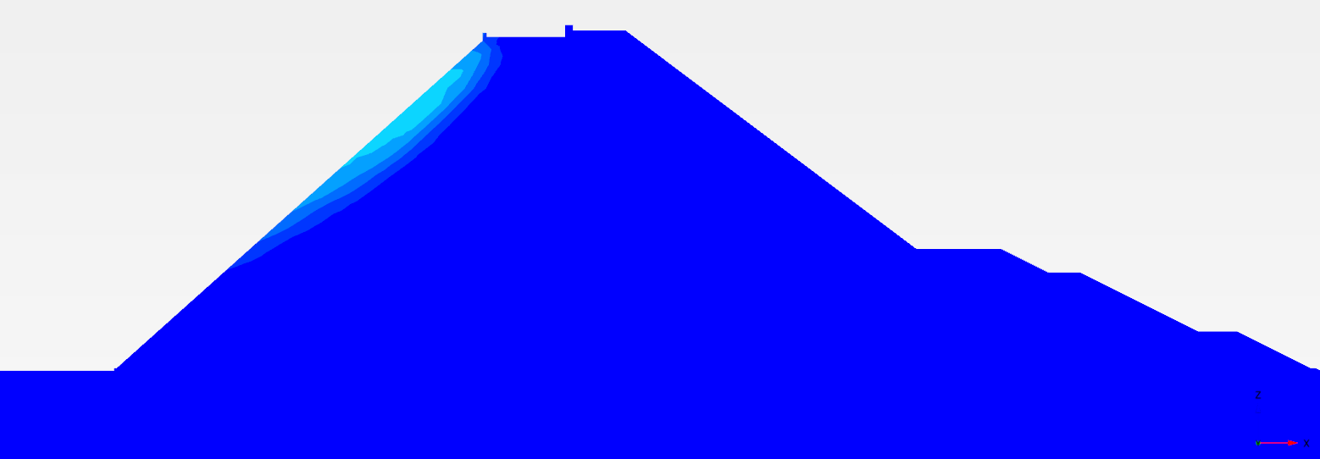
(e)
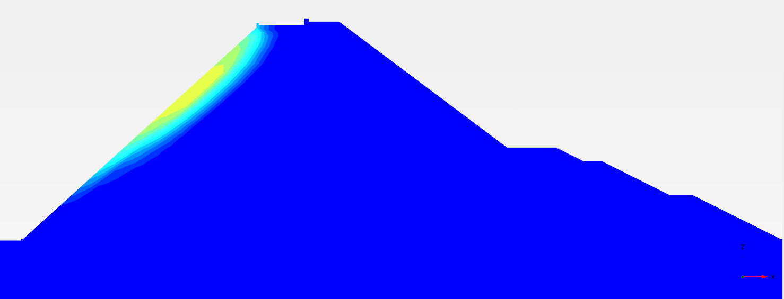
(f)
Figure 15.12 Incremental Displacement and failure pattern of the dyke of (a) 24 m (RL -5 m), (b) 29 m (RL -10 m), (c) 34 m (RL -15 m), (d) 39 m (RL -20 m), (e) 44 m (RL -25 m), and (f) 49 m (RL -30 m) after Breakwater construction
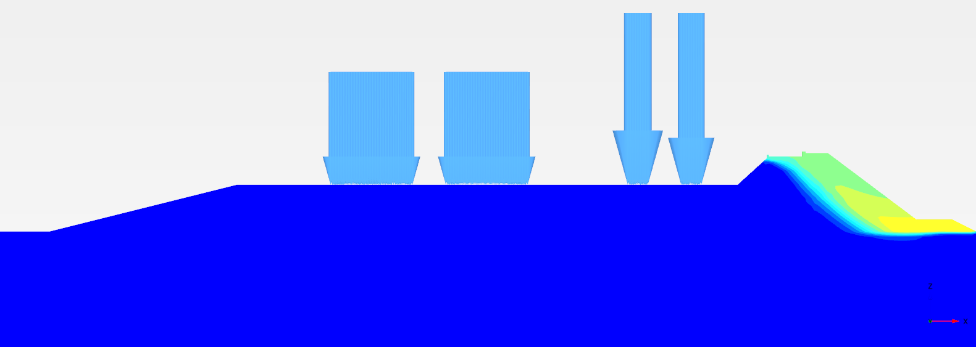 | 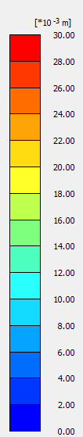
(a)
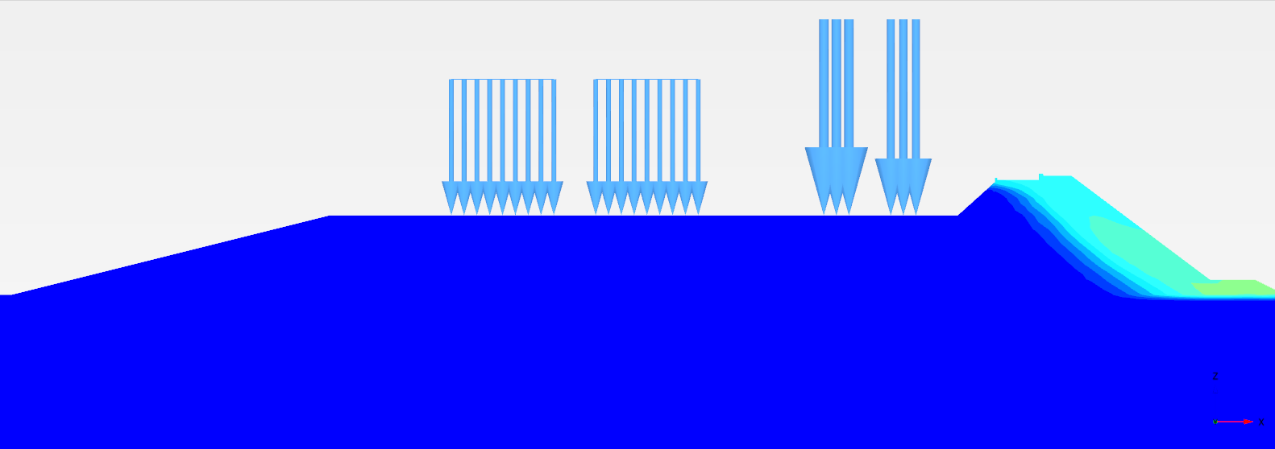
(b)
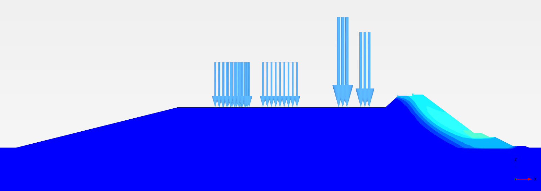
(c)
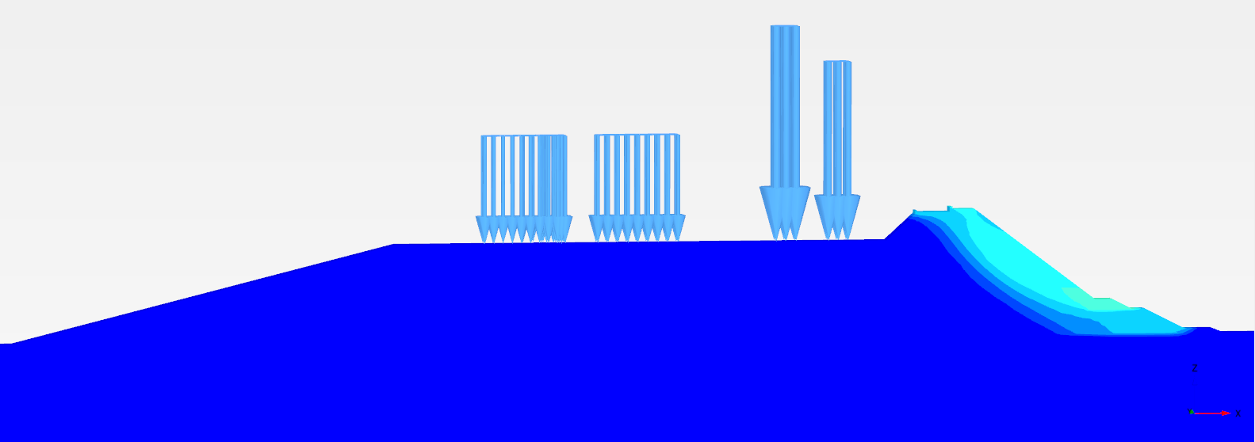
(d)
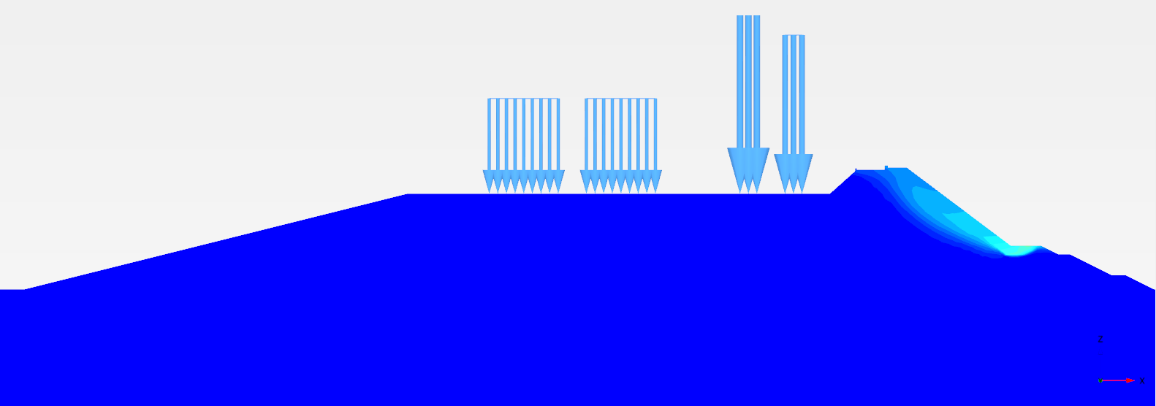
(e)
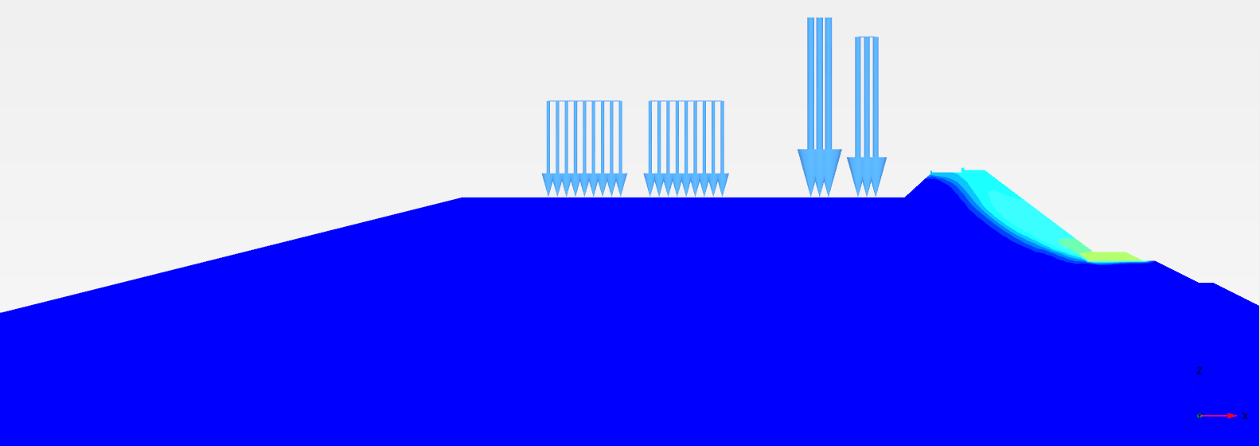
(f)
Figure 15.13 Incremental Displacement and failure pattern of the dyke of (a) 24 m (RL -5 m), (b) 29 m (RL -10 m), (c) 34 m (RL -15 m), (d) 39 m (RL -20 m), (e) 44 m (RL -25 m), and (f) 49 m (RL -30 m) after complete construction
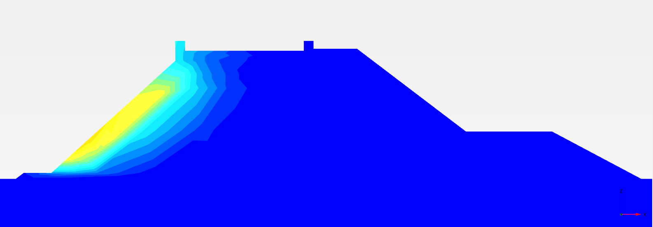 | 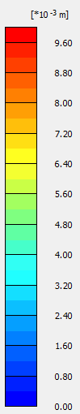
(a)
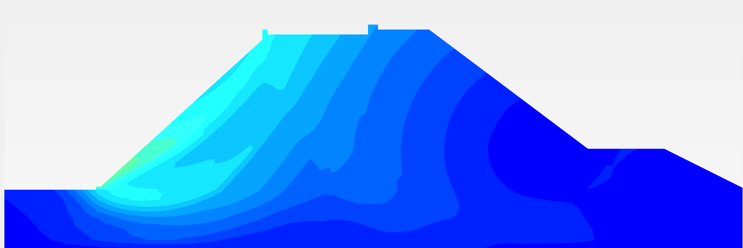
(b)
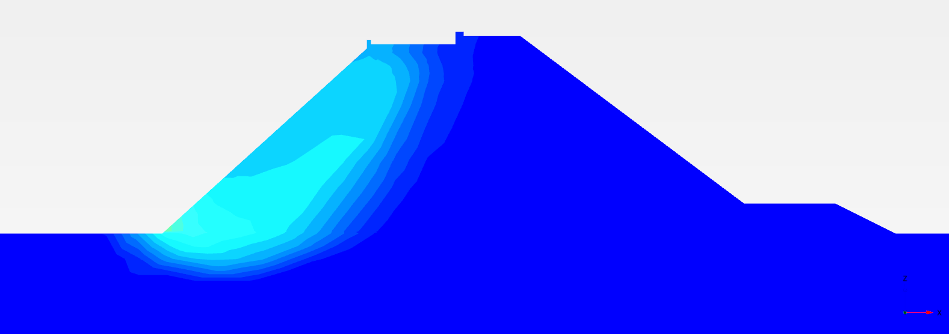
(c)
Figure 15.14 Incremental Displacement and failure pattern of the dyke of (a)7 m (RL +5 m), (b) 16.5 m (RL 0 m), (c) 24 m (RL -5 m) height at the end of breakwater construction.
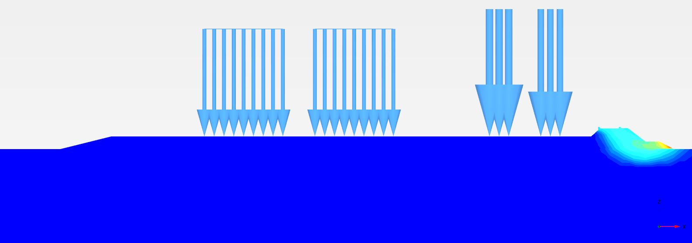 | 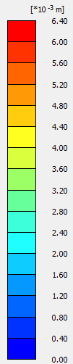
(a)
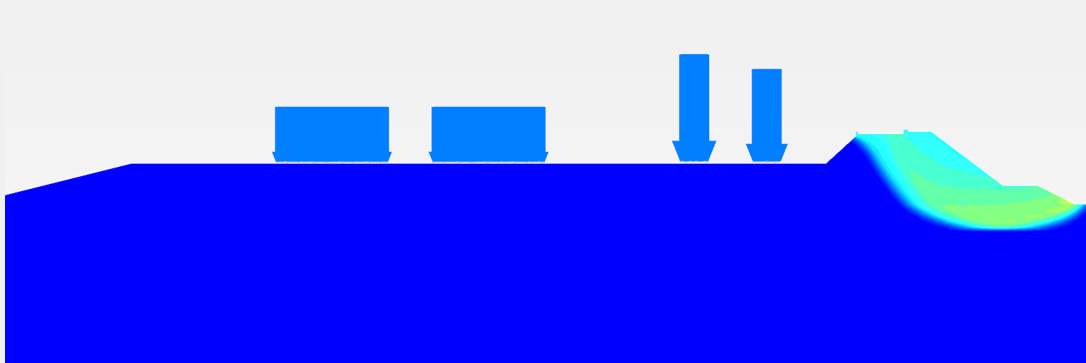
(b)
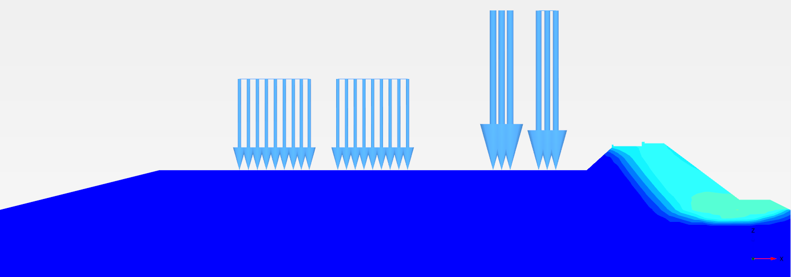
(c)
Figure 15.15 Incremental Displacement and failure pattern of the dyke of (a)7 m (RL +5 m), (b) 16.5 m (RL 0 m), (c) 24 m (RL -5 m) height after complete construction.
(2) Intertidal zone: Analyses at Bhavnagar and Dahej regions
Figure 15.14 shows the incremental displacement and failure pattern for the dyke of all cross sections after breakwater construction in the intertidal zone. It can be seen from the Figure 15.14 that the plastic strains developed along the reservoir side slope of the breakwater and the failure pattern shifted to the seaside of the breakwater after embankment construction (Figure 15.15).

(b) Equivalent Static
Equivalent static method is carried out to assess the performance of the dyke cross sections under two earthquake loading conditions having PGA of 0.225g and 0.36g. The details about the location of failure pattern of slopes and factor of safety values for both gulf and intertidal zone are discussed in this subsection.
(1) Intertidal zone: Analyses at Bhavnagar and Dahej regions
Figure 15.17 shows the incremental displacement and failure pattern for the dyke of all cross sections in the intertidal zone under equivalent static loading 0.36g PGA. It can be seen that displacements increase towards the reservoir side, and deep-seated pattern is observed for all the cross sections corresponding to the borehole GT/SPT2.
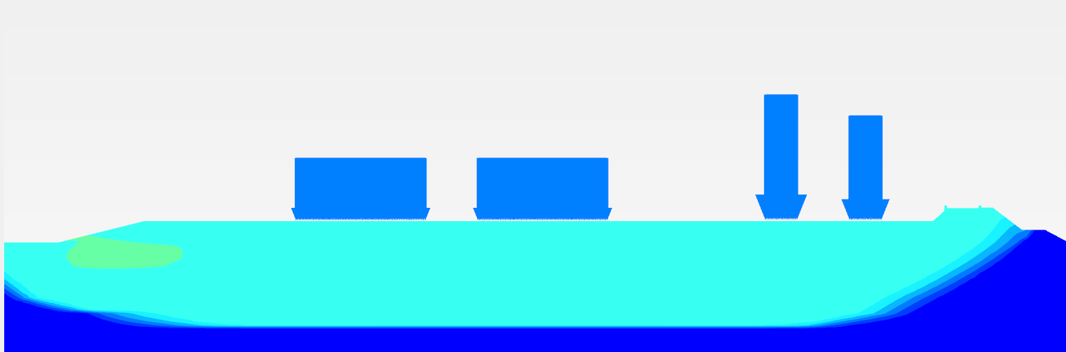 | 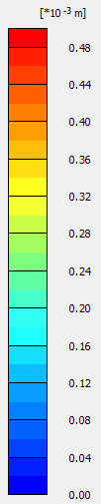
(a)
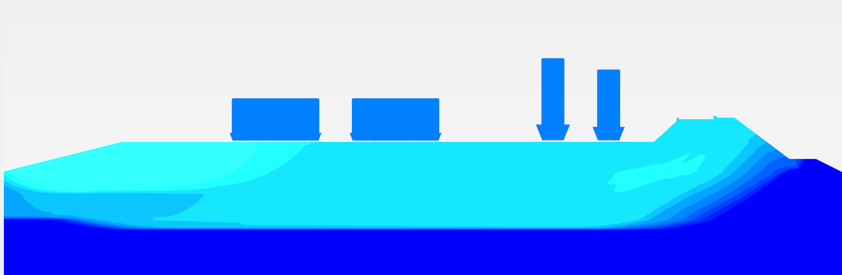
(b)
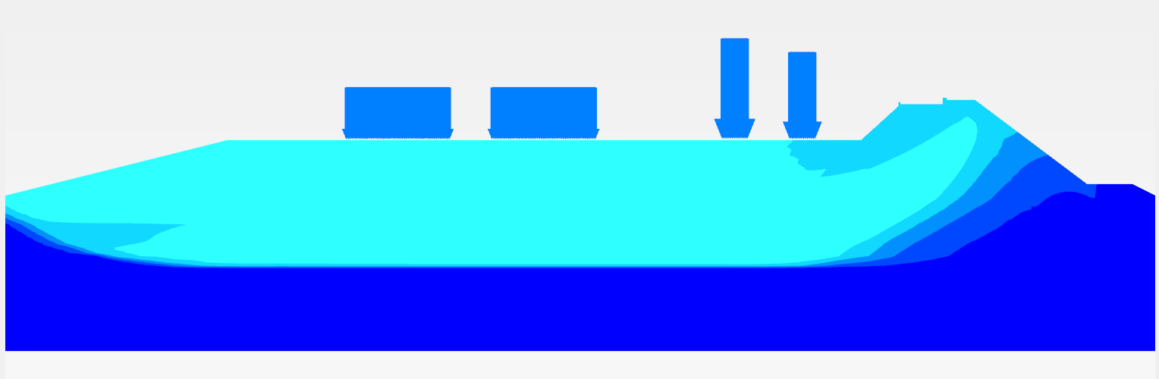
(c)
Figure 15.17 Incremental Displacement and failure pattern of the dyke of (a)7 m (RL +5 m), (b) 16.5 m (RL 0 m), (c) 24 m (RL -5 m) height under equivalent static loading of 0.36g acceleration (GT/SPT 2).

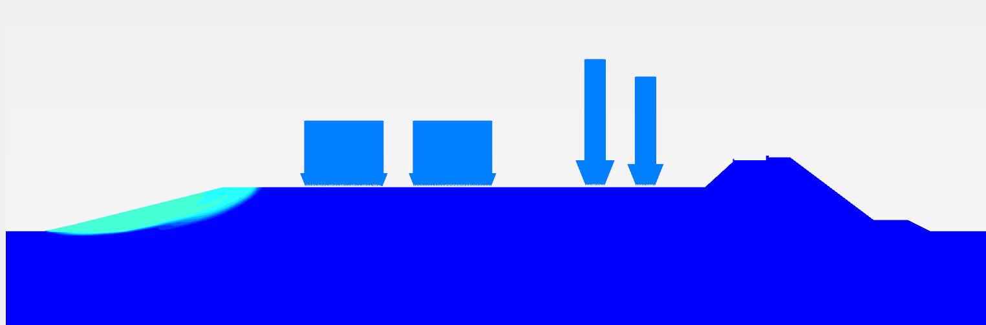 | 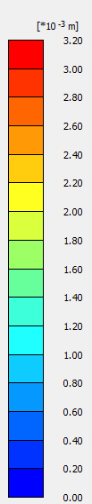
(a)
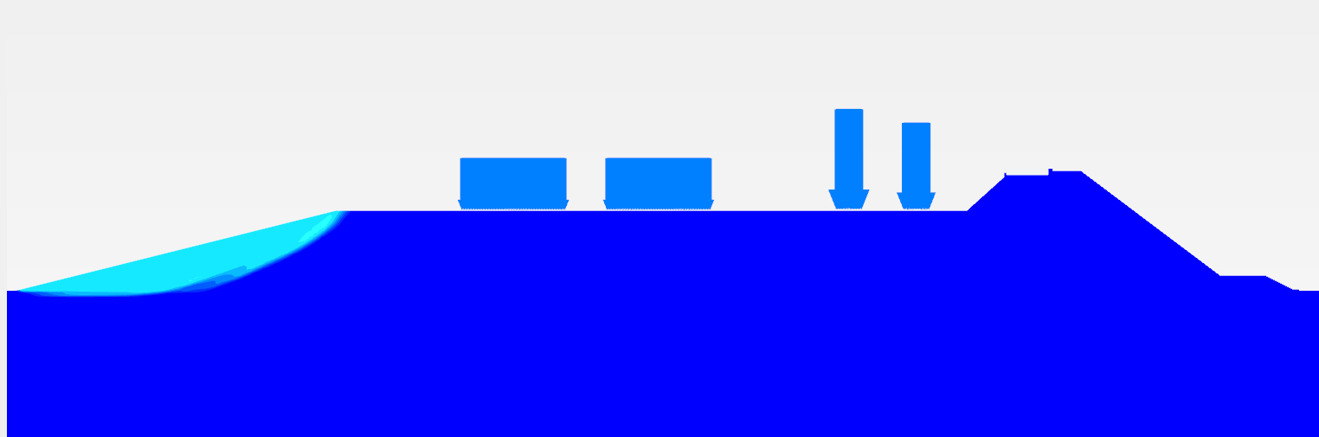
(b)
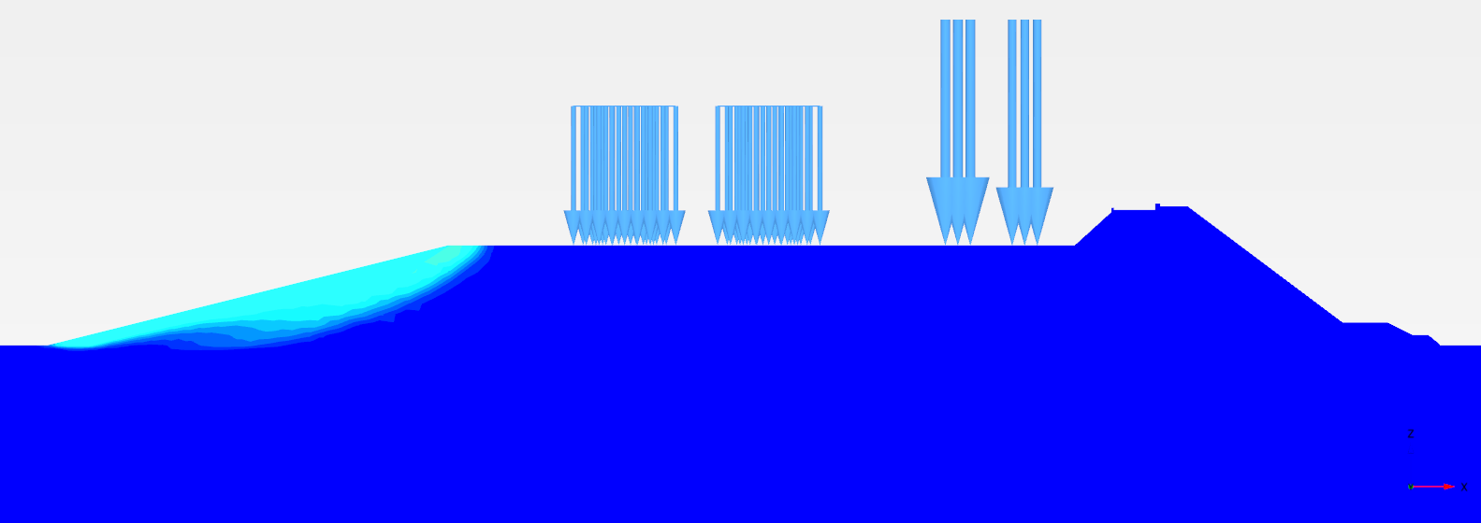
(c)
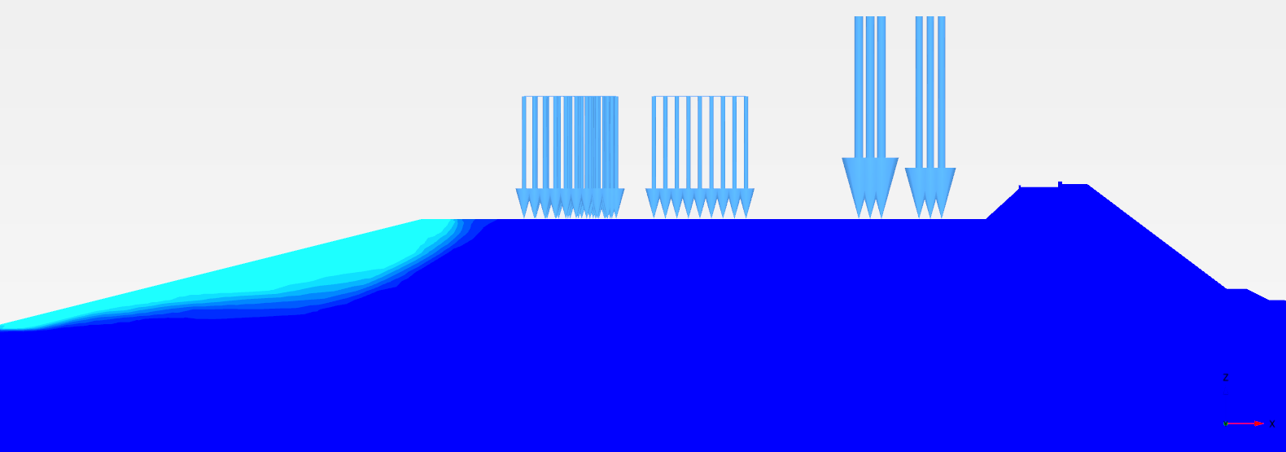
(d)
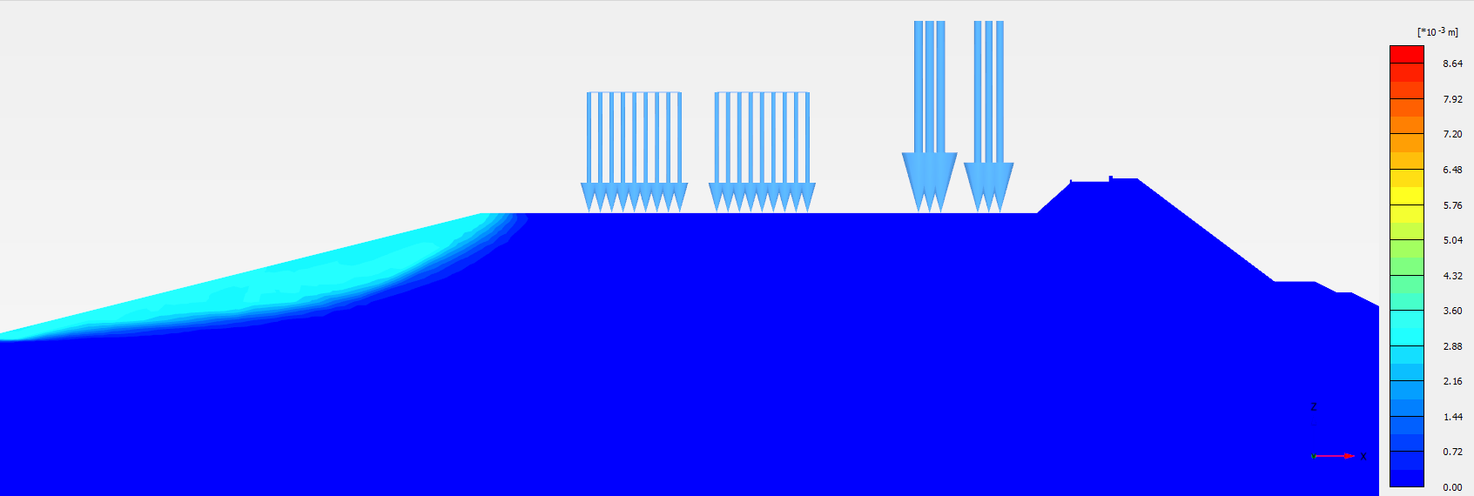
(e)
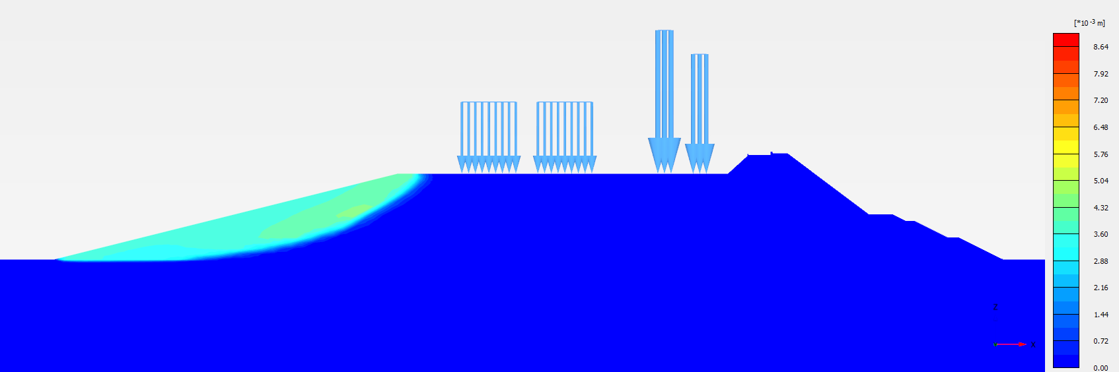
(f)
Figure 15.16 Incremental Displacement and failure pattern of the dyke of (a) 24 m, (b) 29 m, (c) 34 m, (d) 39 m, (e) 44 m, and (f) 49 m under equivalent static (0.36g PGA)

(2) Gulf region
Initially, plastic stress strain analysis is carried out with an equivalent static load of 0.225g and 0.36g. The developed pore water pressures are used in stability analysis to find the factor of safety values. Figure 15.16 shows the incremental displacement and failure pattern for the dyke of all cross sections under all four loading conditions. It can be seen from Figure 15.16 that the plastic strains developed in stability analysis on the reservoir side slope due to equivalent static load of 0.36g PGA.

(c) Summary
The factor of safety for all the sections under static and equivalent static condition with steady state seepage is presented in Table 15.8. All the sections considered in the present study are found to achieve adequate factor of safety for all the loading conditions.
Table 15.8 Summary of factor of safety values for cross sections corresponding to heights of the dyke
Gulf region (GT/SPT 7) – Factor of safety
Height of the dyke (m) | At the end of  Breakwater construction | At the end of embankment construction | Live Load | Equivalent static
 |  |  |  | 0.225g | 0.36g
24 | 1.3 | 1.9 | 1.9 | 1.2 | 1.1
29 | 1.3 | 1.9 | 1.9 | 1.4 | 1.1
34 | 1.2 | 1.8 | 1.8 | 1.4 | 1.1
39 | 1.1 | 1.8 | 1.8 | 1.4 | 1.1
44 | 1.2 | 2 | 2 | 1.4 | 1.1
49 | 1.2 | 2 | 2 | 1.3 | 1.1
Bhavnagar region (GT/SPT 2)
7.5 | 2.3 | 2.9 | 2.9 | 2 | 1.5
16 | 1.4 | 1.8 | 1.7 | 1.5 | 1.2
24 | 1.4 | 1.6 | 1.6 | 1.4 | 1
Bhavnagar region (GT/SPT 3)
7.5 | 1.6 | 2 | 2 | 1.5 | 1.3
16 | 1.3 | 1.8 | 1.8 | 1.3 | 1.1
24 | 1.2 | 1.7 | 1.7 | 1.3 | 1
Dahej region (GT/SPT 12)
7.5 | 1.5 | 2.1 | 2.1 | 1.5 | 1.3
16 | 1.3 | 1.9 | 1.9 | 1.3 | 1.1
24 | 1.2 | 1.7 | 1.7 | 1.3 | 1
Dahej region (GT/SPT 13)
7.5 | 1.5 | 2 | 2 | 1.6 | 1.2
16 | 1.3 | 1.9 | 1.9 | 1.3 | 1.1
24 | 1.2 | 1.7 | 1.7 | 1.4 | 1

14.2.4 Strength Design
a) Static
The plastic stress-strain analysis is carried out for all cross sections in the gulf region and intertidal zone. Details about the deviatoric stress variation for different dyke cross sections under various loading conditions are discussed in this section.
(2) Intertidal zone: Analyses at Bhavnagar and Dahej regions
There are certain top layers of weak soil strata available in the intertidal zone having inadequate Bearing capacity. Ground improvement using Stone Columns is proposed, and improved properties (Table 15.16) are used to find the soil bearing capacity. Figure 15.19 shows the Deviatoric stress variation for all cross sections in the intertidal zone under two loading conditions (Dead Load + Imposed Load).
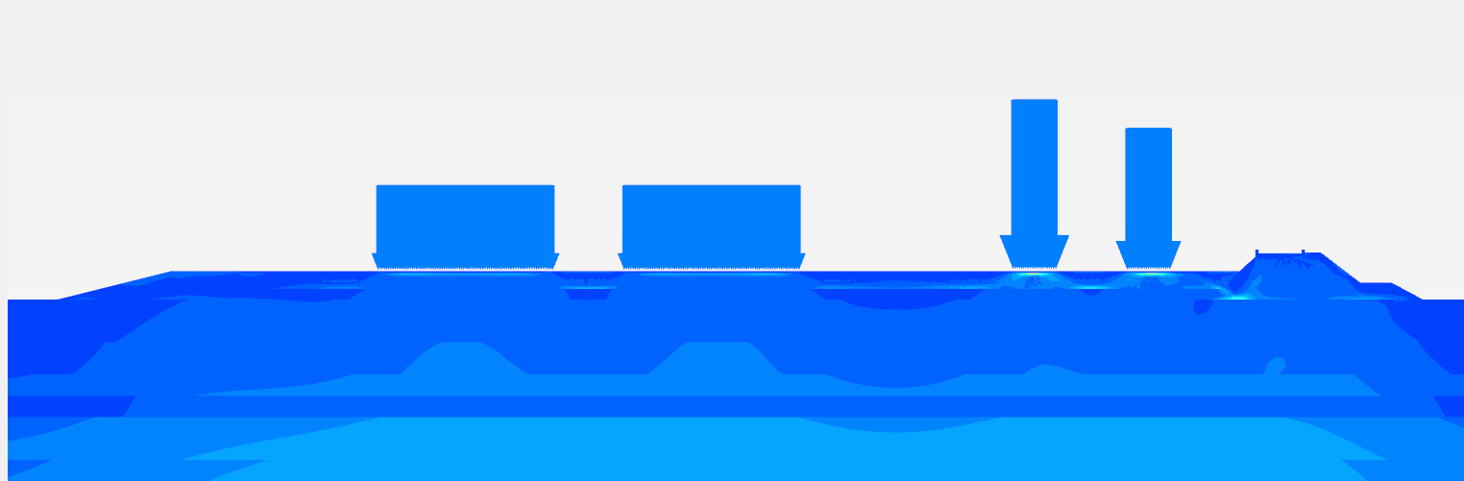 | 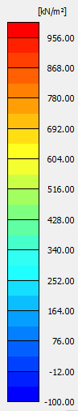
(a)
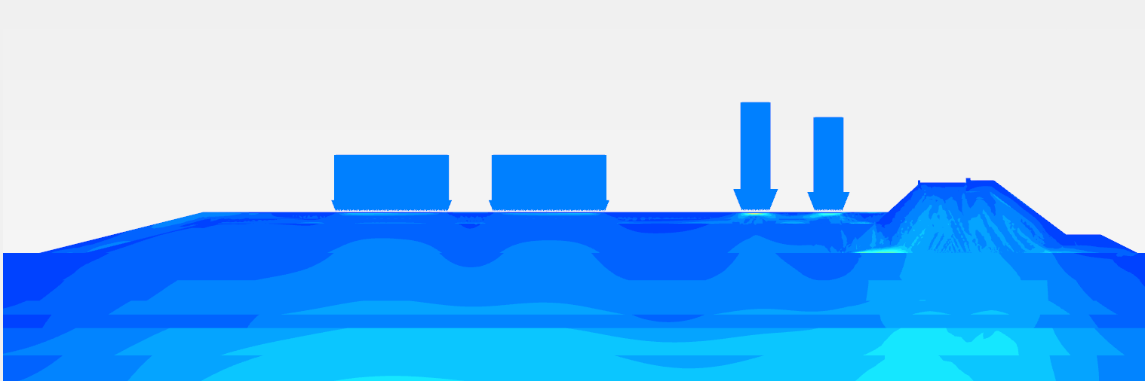
(b)
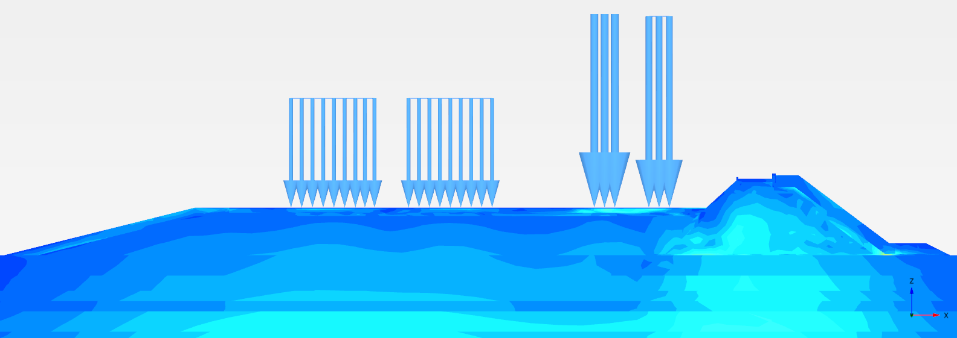
(c)
Figure 15.19 Deviatoric stress variation corresponding to various cross sections of dyke (a)7 m (RL +5 m), (b) 16.5 m (RL 0 m), (c) 24 m (RL -5 m) height for GT/SPT 2
(1) Gulf region: Analyses for GT/SPT7
In gulf region, bearing capacity of soil is high as the soil is predominantly silty sand in nature. However, certain layers are found to be potentially liquefiable, and vibro compaction technique is proposed for mitigation. Figure 15.18 shows the deviatoric stress variation for different heights of the dyke considering two loading conditions (Dead Load + Imposed Load). The stresses in the foundation soil are recorded and compared with the Bearing capacity values.
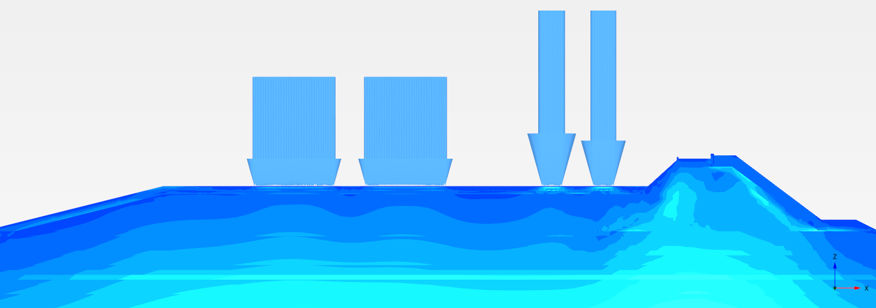 | 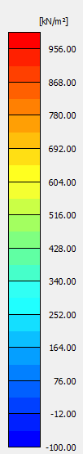
(a)
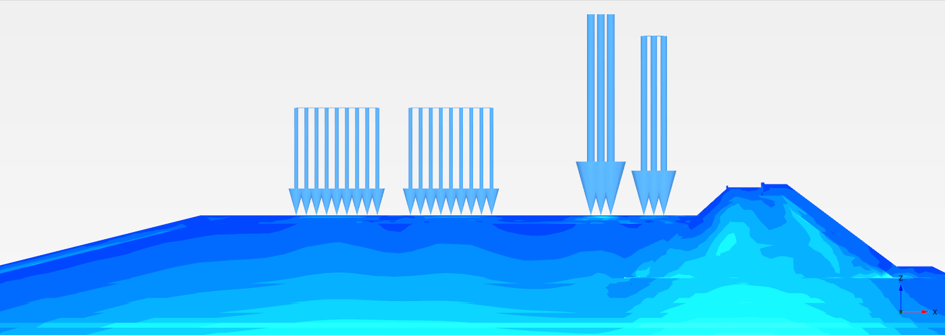
(b)
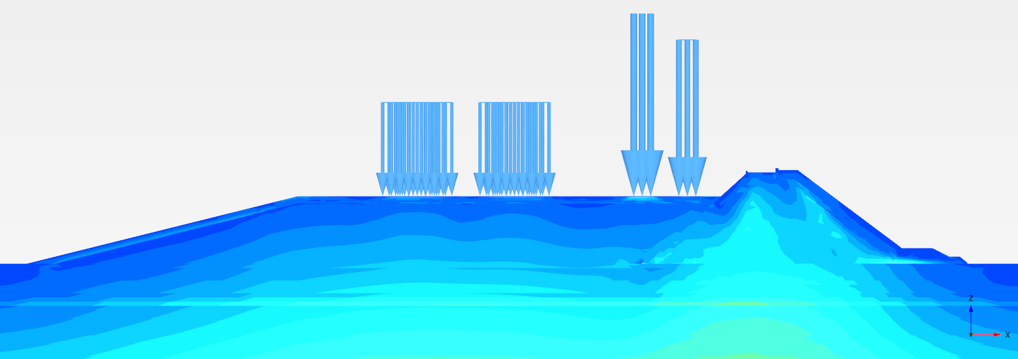
(c)
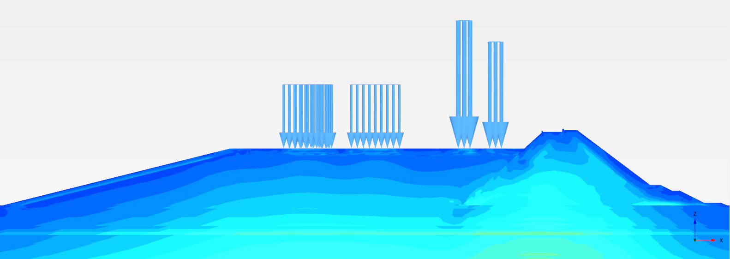
(d)
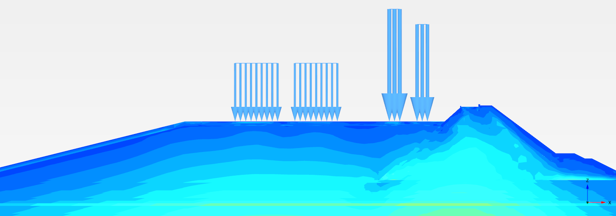
(e)
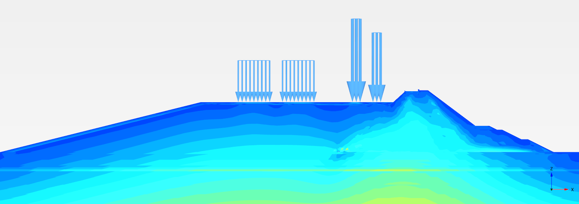
(f)
Figure 15.18 Deviatoric stress variation corresponding to various cross sections of a) 24 m (RL -5 m), (b) 29 m (RL -10 m), (c) 34 m (RL -15 m), (d) 39 m (RL -20 m), (e) 44 m (RL -25 m), and (f) 49 m (RL -30 m) height

(b) Equivalent static
(1) Intertidal zone: Analyses at Bhavnagar and Dahej regions
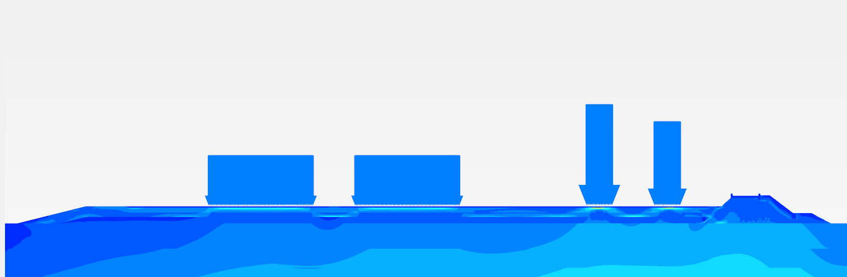 | 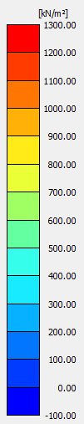
(a)
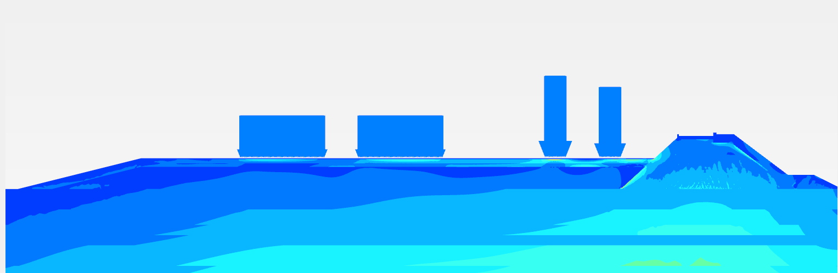
(b)
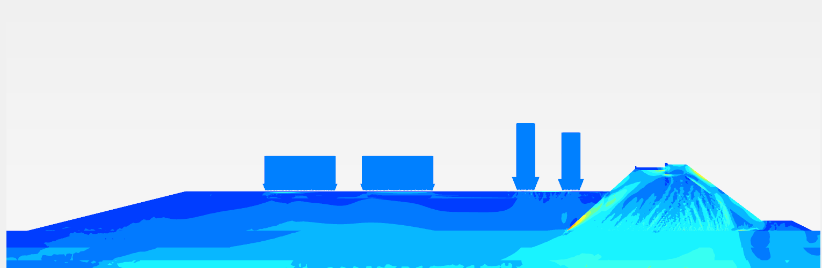
(c)
Figure 15.21 Deviatoric stress variation construction for the height of the dyke of (a)7 m (RL +5 m), (b) 16.5 m (RL 0 m), (c) 24 m (RL -5 m) under equivalent static load of 0.36g
(2) Gulf region: Analyses for GT/SPT7
After the application of static loads as discussed in previous section, equivalent static forces corresponding to the earthquakes 0.225g and 0.36g are applied to the existing stresses, and the deviatoric stress variation (0.36g PGA) for all the cross sections at gulf region are shown in Figure 15.20.
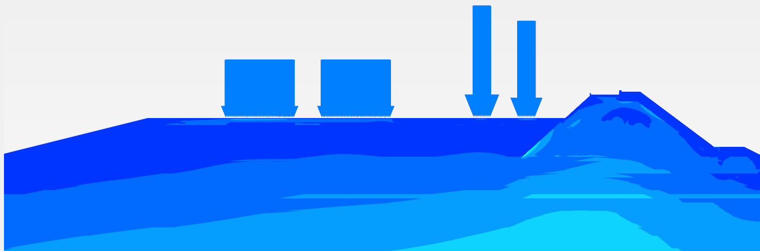 | 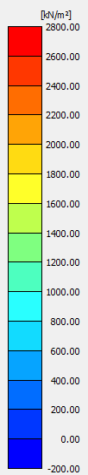
(a)
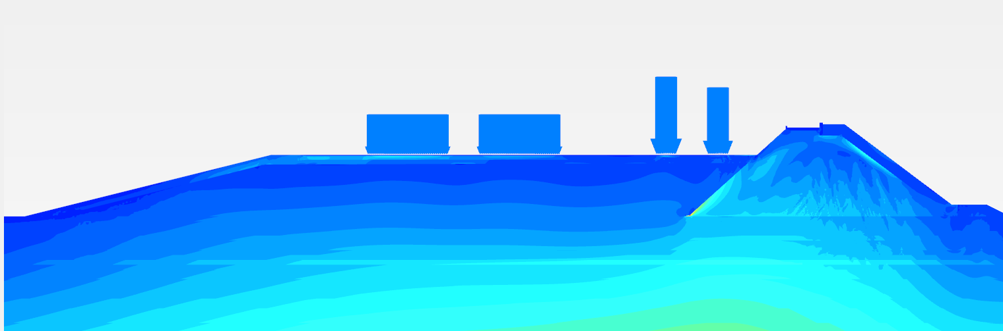
(b)
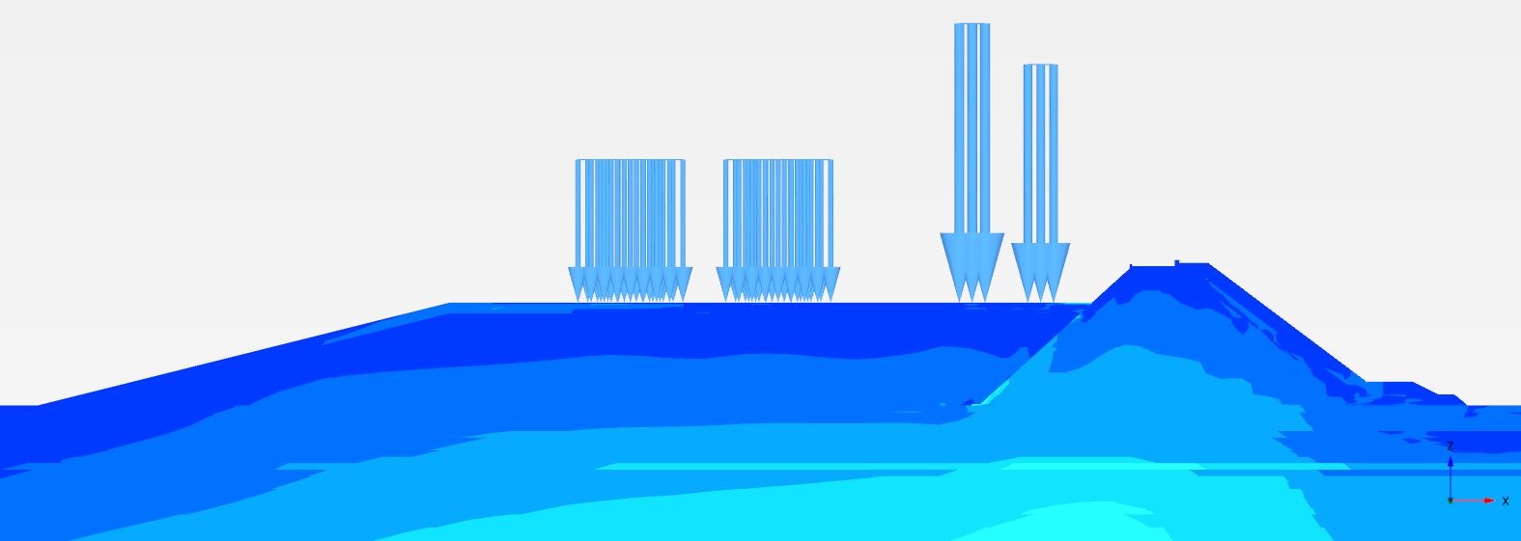
(c)
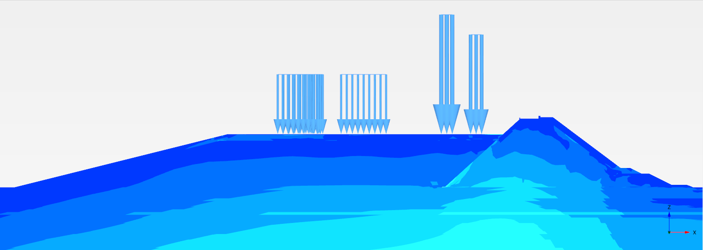
(d)
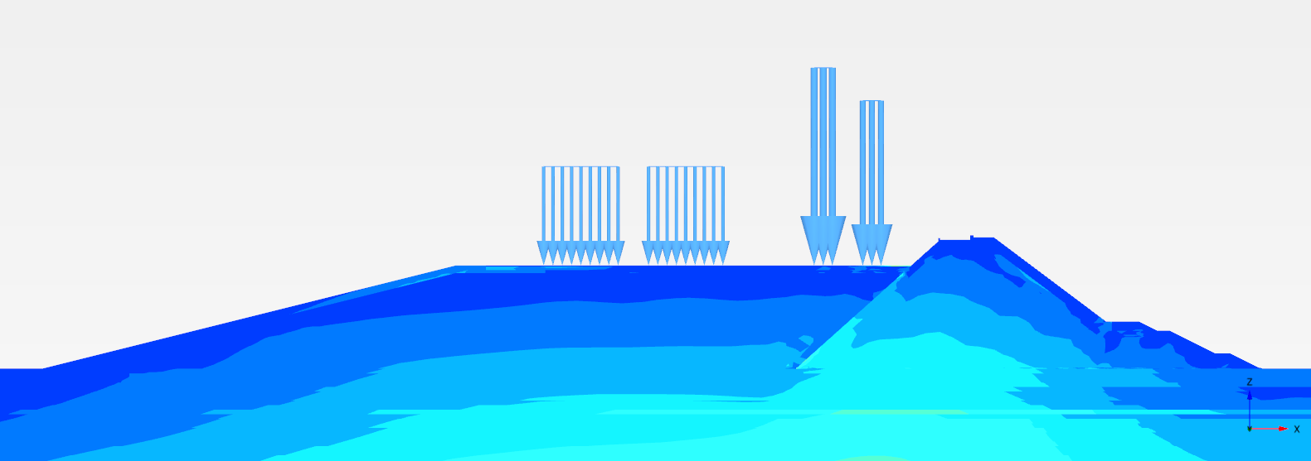
(e)
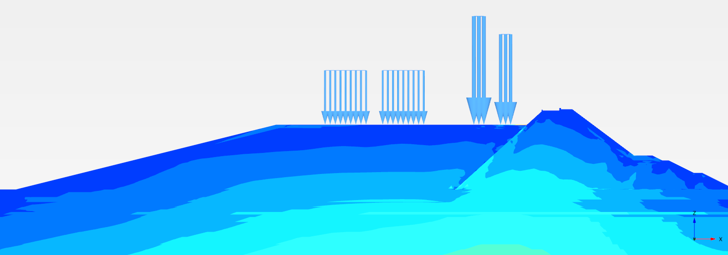
(f)

Figure 15.20 Deviatoric stress variation corresponding to various cross sections of a) 24 m (RL -5 m), (b) 29 m (RL -10 m), (c) 34 m (RL -15 m), (d) 39 m (RL -20 m), (e) 44 m (RL -25 m), and (f) 49 m (RL -30 m) height

(c) Dynamic
(1) Gulf region
Dynamic analyses are carried out by considering acceleration time histories having PGA (0.225g and 0.36g). Deviatoric stress variation during earthquake loading is recorded at the top of ACCROPODE II and below the breakwater, as shown in Figure 15.22. Two critical cases are considered for deviatoric stress variation: 1) 49 m Dyke height at Gulf region 2) 24 m Dyke height at intertidal region under earthquake loading (0.36g PGA) as shown in Figures. It can be inferred from the Figures 15.23 and 15.24 shows the maximum deviatoric stresses for ACCROPODE II are within the elastic range. The stresses in the foundation soil are within the calculated bearing capacity as shown in the Table 15.9.
Figure 15.22 Considered two points to record deviatoric stress variation A) ACCROPODE II B) Below the Breakwater
(a)
(b)
Figure 15.23 Deviatoric stress variation for 24 m height of the dyke (GT/SPT2) at two points under earthquake loading (0.36g PGA) a) ACCROPODE II b) Below the Breakwater
(a)
(b)
Figure 15.24 Deviatoric stress variation corresponding to 24 m height of the dyke (GT/SPT2) at two points a) ACCROPODE II b) Below the Breakwater

(d) Summary
The allowable bearing capacity calculations are based on Brinch Hansen's general bearing capacity equation by assuming footing width as the dyke width without embedment in the soil. It can be seen that the deviatoric stresses for all the cases are less than the bearing capacity of soil (Table 15.9).
Table 15.9 Maximum Deviatoric stress in the top foundation soil corresponding to different heights of the dyke
Deviatoric stress (kPa) - Gulf region (GT/SPT 7) |  |  |  |  |  |  |  | Ultimate bearing capacity (kPa)
Height of the dyke (m) | At the end of Breakwater construction | At the end of embankment construction | Live Load | Equivalent static |  | Dynamic |  | Ultimate bearing capacity (kPa)
 |  |  |  | 0.225g | 0.36g | 0.225g | 0.36g | Ultimate bearing capacity (kPa)
24 | 172 | 200 | 190 | 350 | 610 | 180 | 280 | 29650
29 | 185 | 200 | 206 | 600 | 810 | 270 | 300 | 32300
34 | 270 | 280 | 280 | 420 | 730 | 300 | 280 | 35350
39 | 250 | 270 | 270 | 460 | 730 | 330 | 520 | 39175
44 | 270 | 300 | 325 | 530 | 750 | 500 | 520 | 42425
49 | 320 | 320 | 360 | 560 | 900 | 600 | 600 | 45525
Bhavnagar region (GT/SPT 2)
7.5 | 75 | 75 | 80 | 210 | 280 | 100 | 200 | 1220*
16 | 160 | 175 | 180 | 250 | 350 | 150 | 220 | 1460
24 | 190 | 220 | 220 | 330 | 370 | 240 | 360 | 1650

14.2.5 Settlement Design
a) Static
Settlement design in this section is classified into two categories: 1. During construction 2. Effect of creep due to Imposed loads. The plastic stress strain analysis is carried out for all cross sections in the gulf region and intertidal zone considering two loading conditions 1. Dead load 2. Imposed Load. Details about the location and magnitudes of settlement in the cross section under both Dead Load and Imposed Load are discussed in this section.
(1) Gulf region
Construction settlement:
Dyke is constructed in stages of 5 m, initially starting with the breakwater on seaside and then followed by the embankment on the reservoir side, and plastic stress strain analysis is carried out for each phase of construction. The settlement happening at each stage of construction and the total settlement percentage for all the cross sections are shown in Table 15.10. The soil stratum is predominantly silty sand in this region, and the entire settlement will happen immediately. Therefore, the settlement values are not a concern as it is usually placed till proposed level at every stage of dyke construction. It also can be inferred that for settlement due to layer placement of sand is high because of large width when compared to rock fill layer placement.
Table 15.10 Vertical settlement during staged construction for various cross sections
Vertical settlement (mm) during staged construction
Breakwater
Stages | Height of the Dyke
Stages | 49 m | 44 m | 39 m | 34 m | 29 m | 24 m
Stage 1 – 4 m | 34 | 33 | 34 | 38 | 33 | 36
Stage 2 – 9m | 34 | 34 | 35 | 34 | 32 | 31
Stage 3 – 14 m | 36 | 35 | 34 | 32 | 30 | 94
Stage 4 – 19 m | 35 | 33 | 31 | 30 | 80 | *
Stage 5 - 24 m | 32 | 30 | 27 | 80 | * | *
Stage 6 - 29 m | 29 | 26 | 47 | * | * | *
Stage 7 – 34 m | 25 | 55 | * | * | * | *
Stage 8 – 39 m | 65 | *
Stage 9 - 44 m | *
Stage 10 – 49 m
Total settlement | 290 | 246 | 208 | 214 | 175 | 161
2.Breakwater + Embankment
Stage 9 – 4 m | 33 | 32 | 33 | 32 | 32 | 32
Stage 10 – 9 m | 38 | 37 | 37 | 38 | 37 | 44
Stage 11 – 14 m | 44 | 44 | 44 | 44 | 44 | 63
Stage 12 – 19 m | 49 | 49 | 50 | 57 | 47 | *
Stage 13 - 24 m | 55 | 55 | 55 | 80 | * | *
Stage 14 - 29 m | 61 | 61 | 88 | * | * | *
Stage 15 – 34 m | 66 | 90 | * | * | * | *
Stage 16 – 39 m | 69 | *
Total settlement | 415 | 368 | 307 | 251 | 160 | 139
* End of complete construction
Effect of creep:
Creep is the volume change under constant stress over a period. The embankment, in this case, is made up of dredged sand. Sand is permeable in nature, and any change in external stress immediately acts as a change in effective stress in soil skeleton. Therefore, excess pore pressure does not develop. The inelastic time dependent creep deformation occurs immediately following stress changes resulting in instantaneous elastic and plastic deformations.

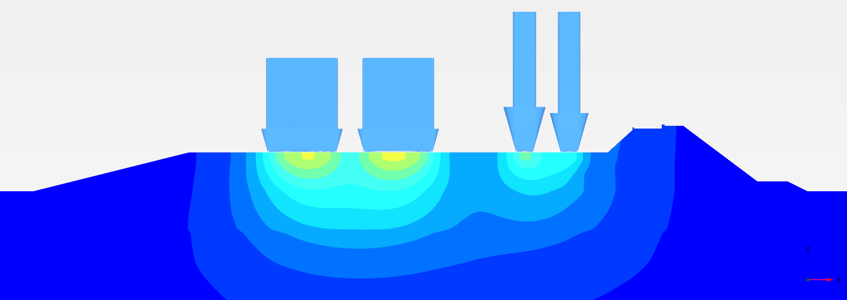 | 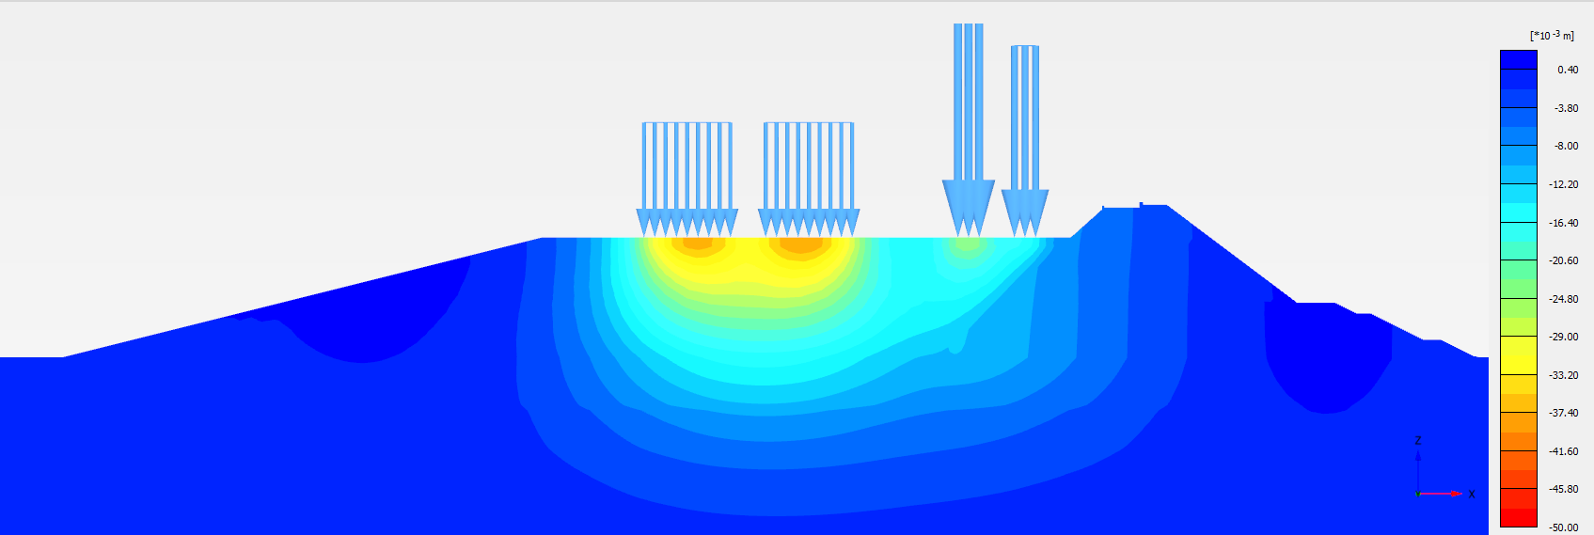
(a)
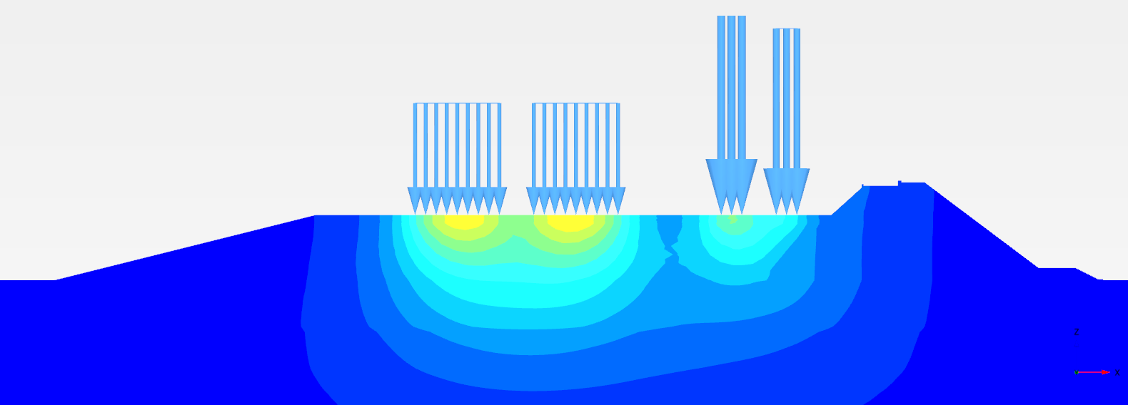
(b)
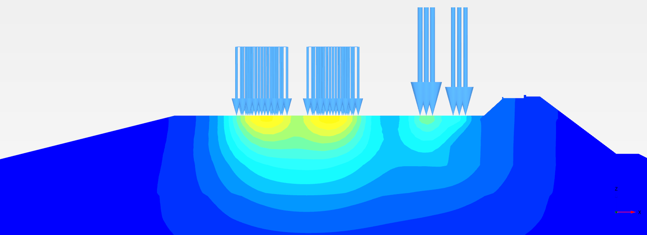
(c)
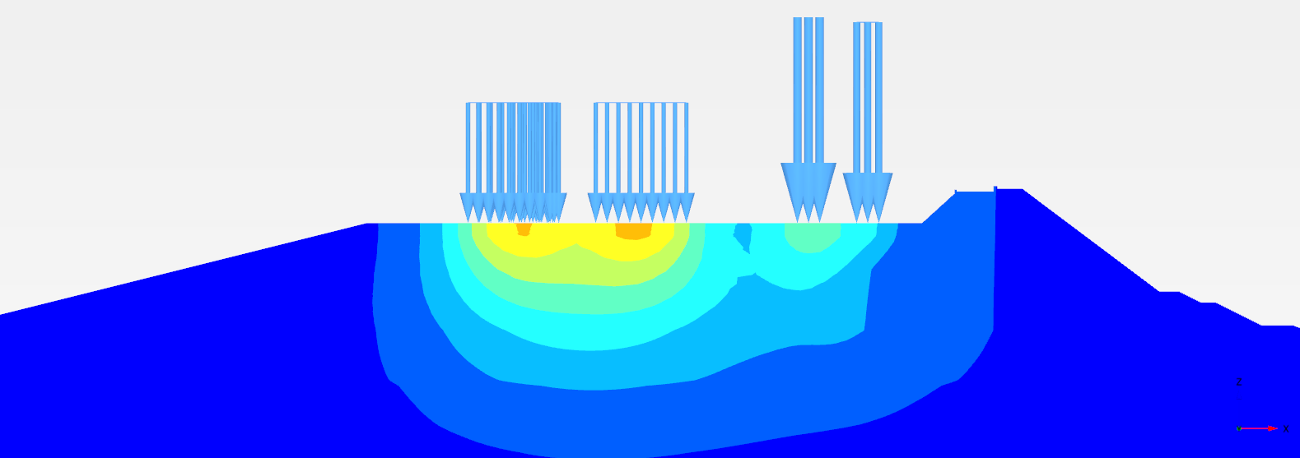
(d)
(e)
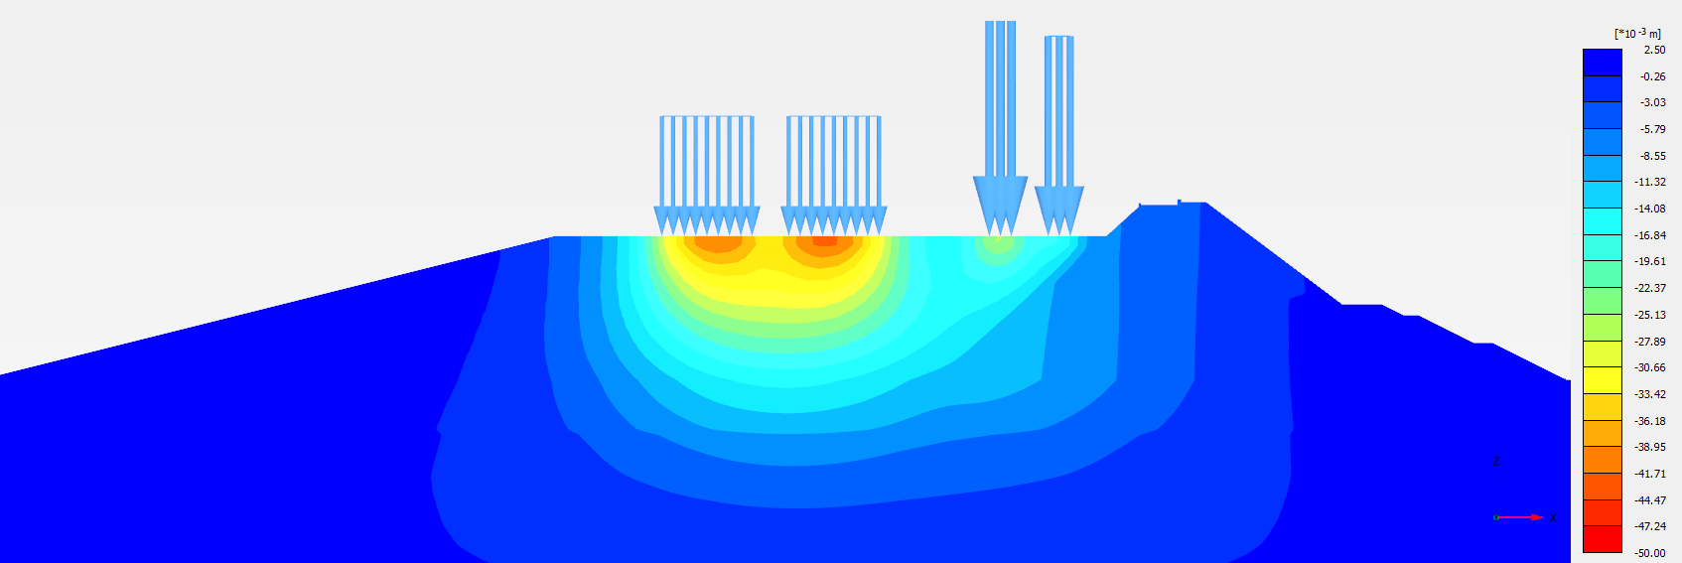
(f)
Figure 15.25 Vertical settlement of the Dyke of (a) 24 m (RL -5 m), (b) 29 m (RL -10 m), (c) 34 m (RL -15 m), (d) 39 m (RL -20 m), (e) 44 m (RL -25 m), and (f) 49 m (RL -30 m)
The plastic deformation in sand occurs due to particle breakage under sustained higher loadings. The progressive breakage of sand particles results in loss of contact between particles causing gradual decrease in soil resistance and stiffness, which increases the settlement with time. The creep deformations in sand depend on applied load and state of packing. As the sand is well compacted and freely draining, no or less creep is expected to develop. Moreover, the height of fill is not very high. Therefore, particle breakage is not expected to occur. It is concluded that the effect of creep is not significant in this case. From analysis, the immediate settlement after placing the vehicular load is approximately 40 mm as shown in Figures 15.25 and 15.26. It is recommended to carry out trial runs with the expected vehicular loads and relay the road for compensating the immediate settlement.
(2) Intertidal zone: Analyses at Bhavnagar and Dahej regions
Ground improvement using stone columns is adopted for top 6 m soft clay corresponding to GT/SPT2 and top 7.5 m corresponding to GT/SPT3. Improved properties as shown in Table 15.16 are considered for the analyses. It is observed from the Table 15.11 that the settlements in this case lie between 47 mm and 250 mm. However, dredging out soft clay is adopted for the areas corresponding to RL -5 m cross section considering stability due to earthquake loading.
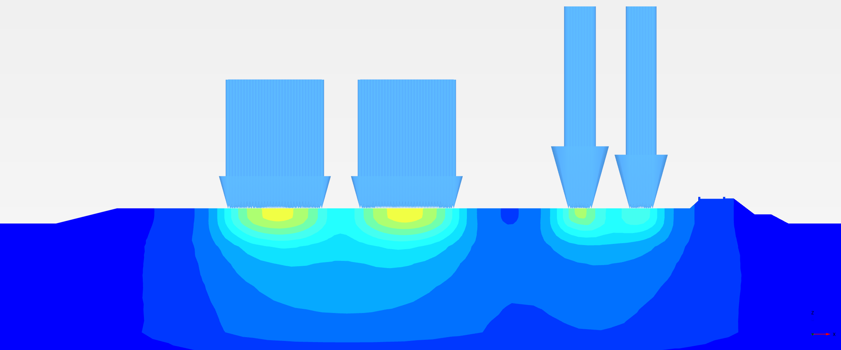 | 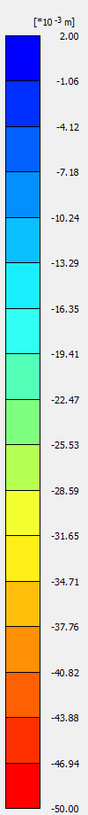
(a)
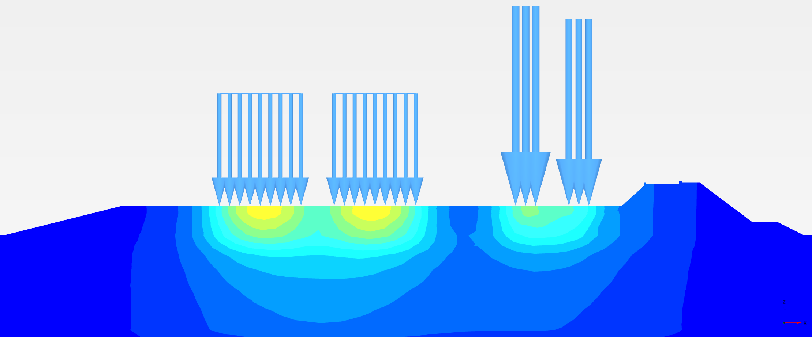
(b)
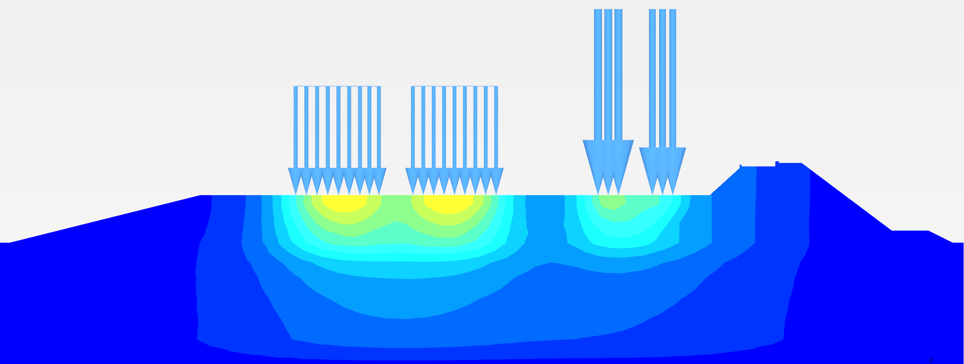
(c)

Figure 15.26 Vertical displacement of the Dyke of (a)7 m (RL +5 m), (b) 16.5 m (RL 0 m), (c) 24 m height under imposed load.

b) Dynamic
Dynamic analysis is carried out for all the cross sections at both gulf and intertidal region considering acceleration time histories (0.225g and 0.36g PGA). In all the cases, lateral spreads are induced along the slopes both on seaside and reservoir side as shown in Figures 13.27 and 13.28. Horizontal displacement is found to be in the range of 170 mm to 350 mm whereas maximum vertical settlement is found to be 100 mm for all the cases as shown in Table 15.11.
(1) Gulf region: Analyses for GT/SPT7
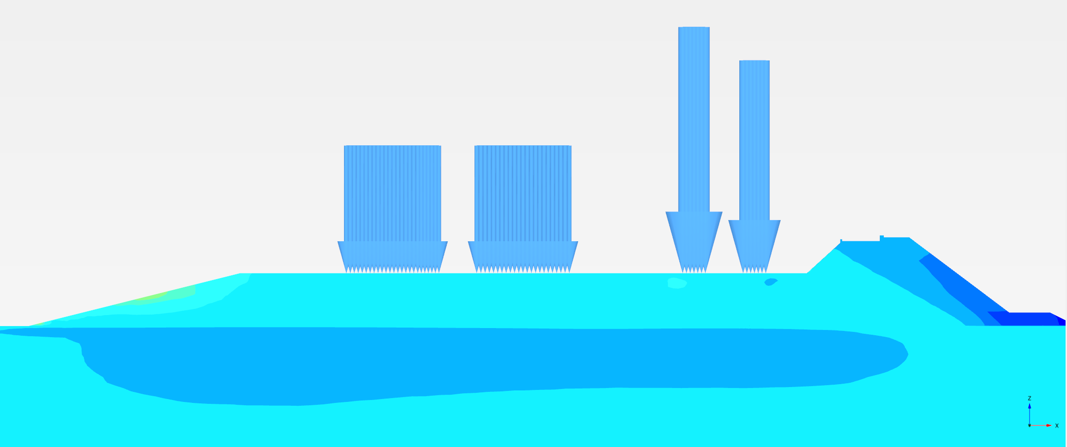 | 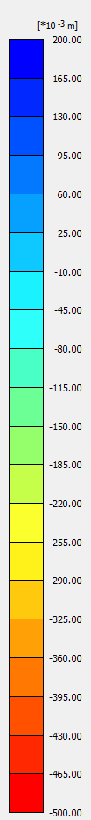
(a)
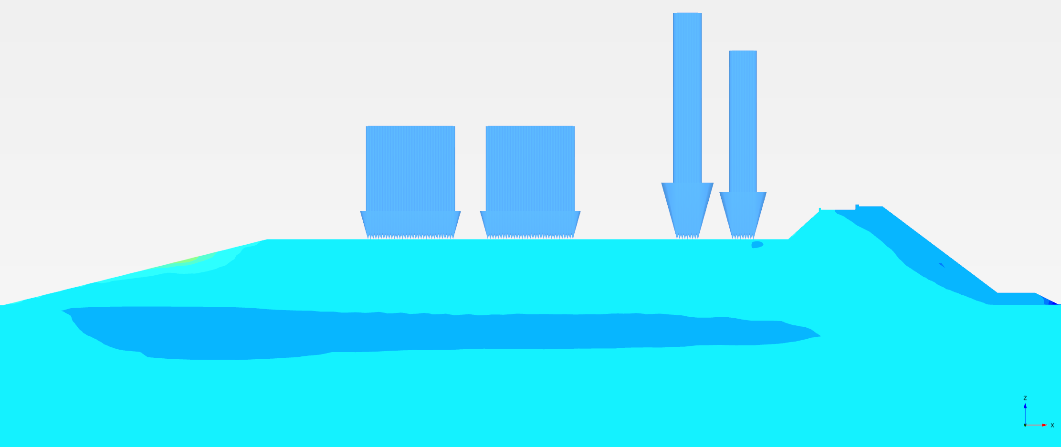
(b)
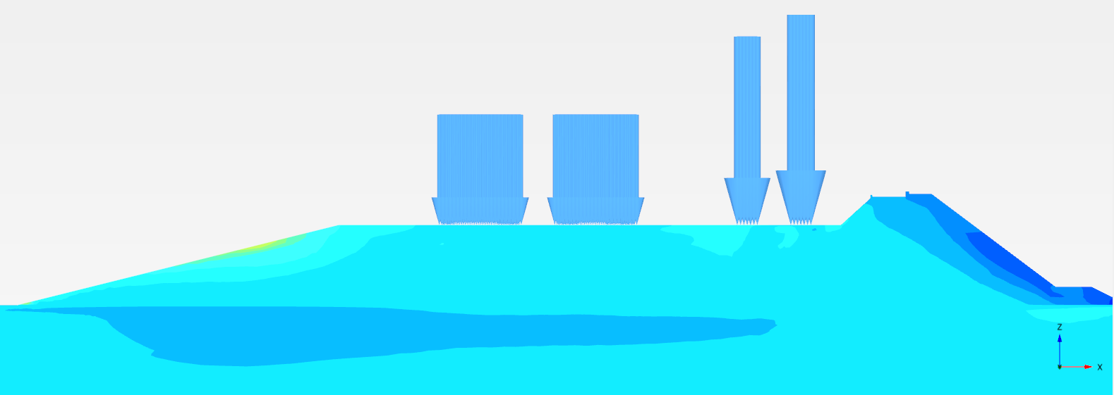
(c)
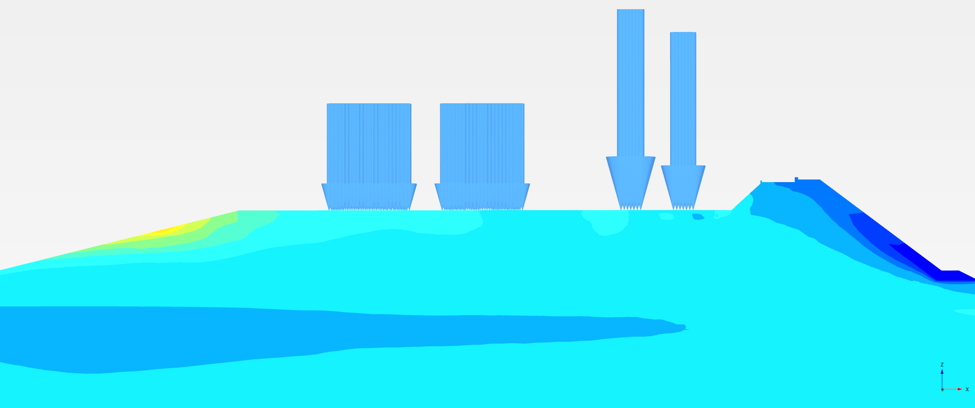
(d)
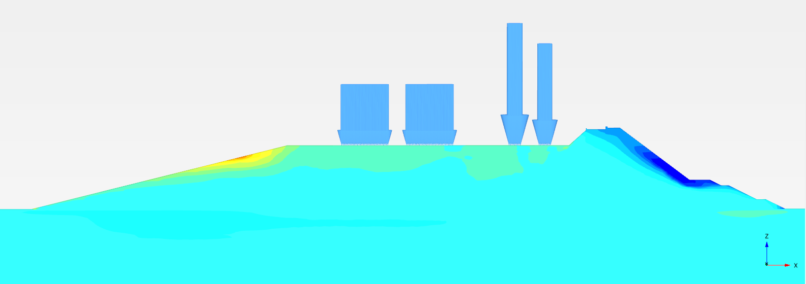
(e)
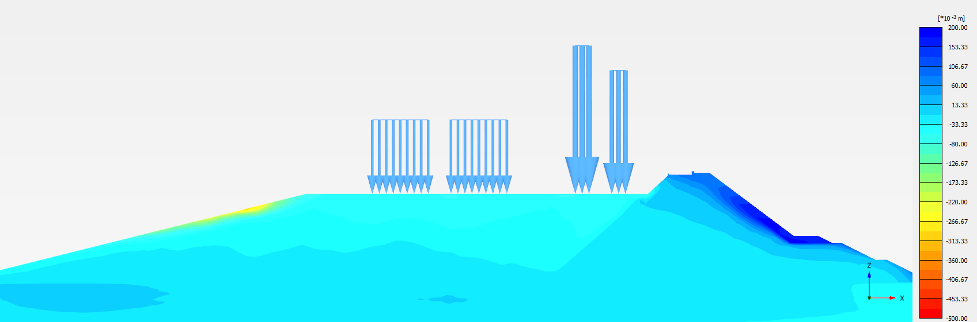
(f)
Figure 15.27 Horizontal settlement of the Dyke of (a) 24 m (RL -5 m), (b) 29 m (RL -10 m), (c) 34 m (RL -15 m), (d) 39 m (RL -20 m), (e) 44 m (RL -25 m), and (f) 49 m (RL -30 m) height under dynamic condition (0.36g PGA)

(2) Intertidal zone: Analyses at Bhavnagar and Dahej regions
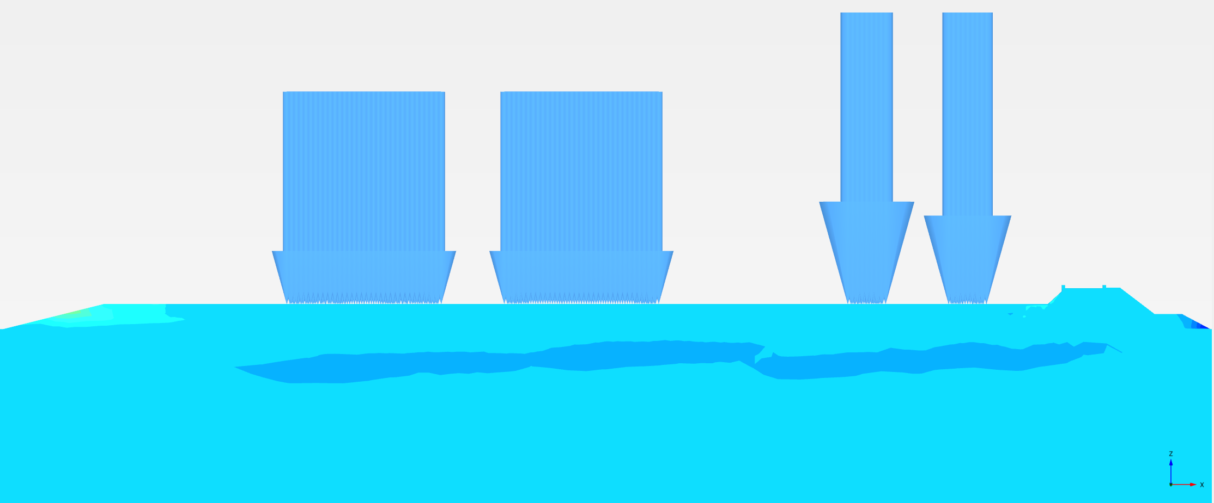
(a)
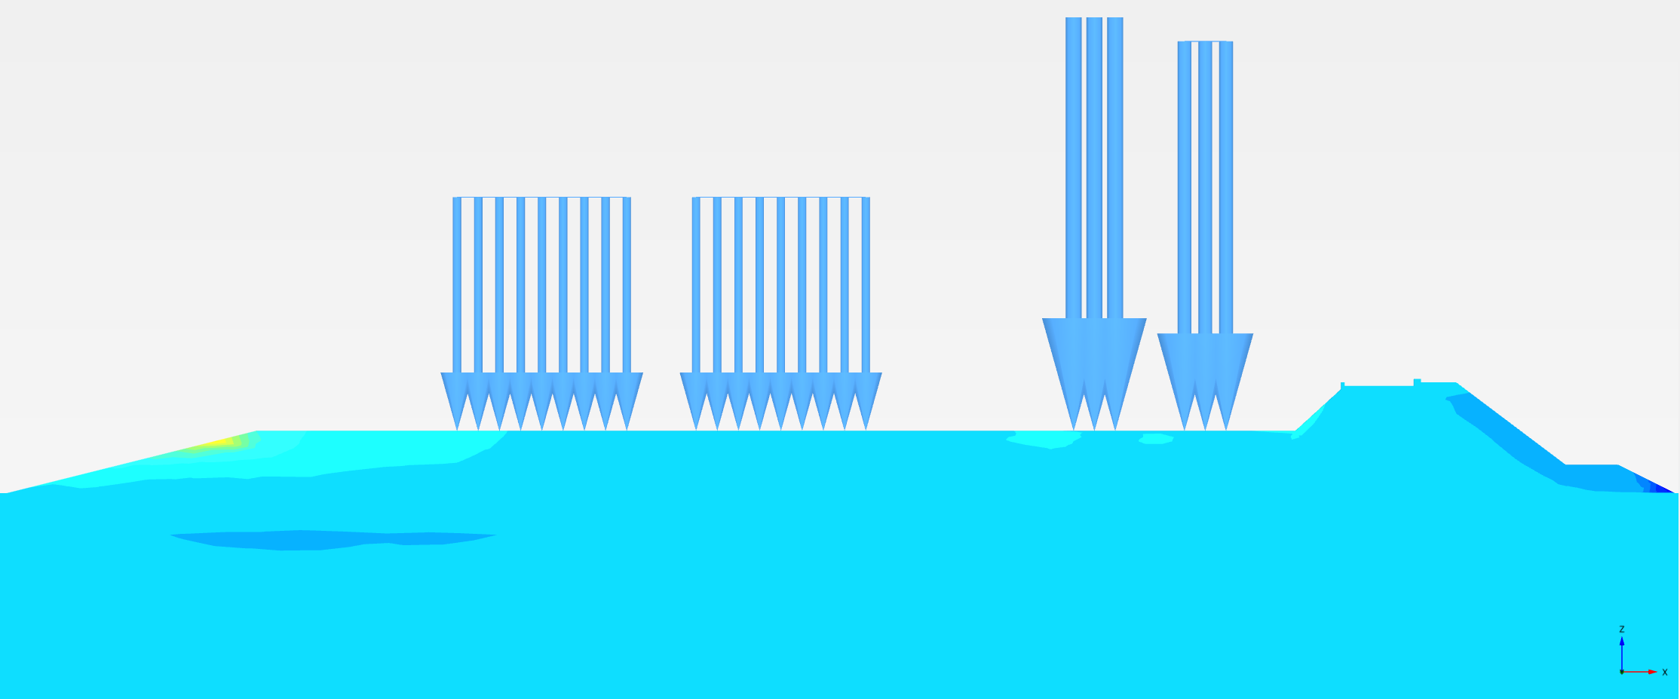
(b)
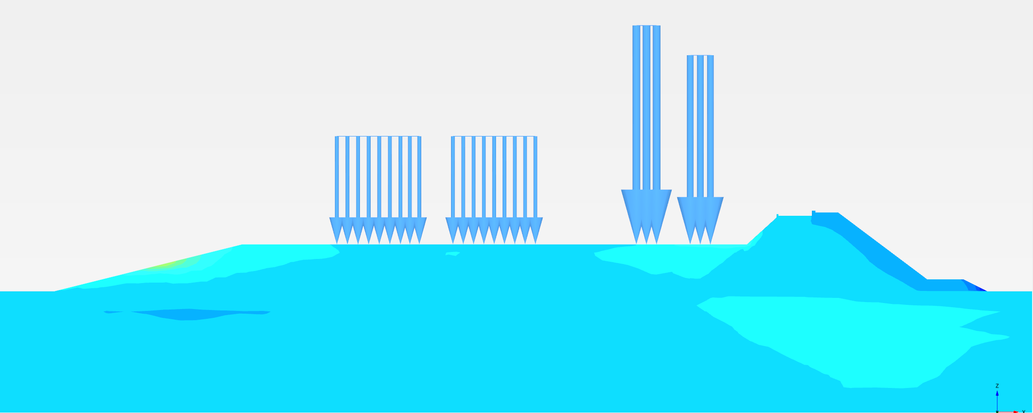
(c)
Figure 15.28 Horizontal settlement of the Dyke of (a) 7 m (RL +5 m), (b) 16.5 m (RL 0 m), (c) 24 m (RL -5 m) height under dynamic condition (0.36g PGA) corresponding to GT/SPT 2
c) Summary
Table 15.11 Summary of settlement for various cross sections under different loading conditions
Settlement (mm) - Gulf region
Height of the dyke (m) | At the end of Breakwater construction | At the end of embankment construction | Imposed Load | Dynamic
 |  |  |  | Vertical |  | Horizontal
 |  |  |  | 0.225g | 0.36g | 0.225g | 0.36g
24 | 161 | 140 | 29 | 20 | 40 | 140 | 200
29 | 175 | 160 | 32 | 32 | 63 | 120 | 170
34 | 214 | 250 | 35 | 63 | 45 | 130 | 210
39 | 208 | 310 | 36 | 50 | 55 | 174 | 320
44 | 246 | 370 | 40 | 45 | 75 | 184 | 350
49 | 290 | 415 | 43 | 48 | 75 | 205 | 330
Bhavnagar region
7.5 | 50 | 47 | 30 | 25 | 20 | 140 | 150
16 | 80 | 120 | 35 | 25 | 20 | 140 | 270
24 | 250 | 234 | 35 | 20 | 31 | 97 | 190

14.2.6 Seepage Design
The seepage quantity is calculated from a steady state flow analysis with MSL on the seaside and varying water levels on the reservoir side (Figure 15.30). The quantity of seepage is obtained at the location of the reservoir slope, as shown in Figure 15.29.
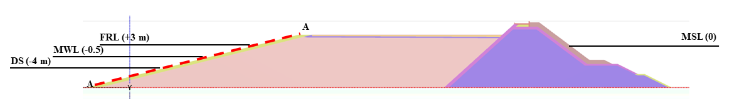
Figure 15.29 The location in the reservoir slope where quantity of seepage is computed: Section A-A
a) Full Reservoir Level – Mean Sea Level
FRL on the reservoir side and MSL on seaside are considered, and seepage analysis is carried out for all the cross sections along the Dyke length. This condition exists for two months, as shown in Figure 15.31. The quantity of seepage from reservoir to seaside is very high as shown in Table 15.12, however it is not critical condition.
(b) Mean Reservoir Level – Mean Sea Level
This condition is assumed to exist for 7 months, and seepage analysis is carried out for all the cross sections. In this case, head difference causes seepage flow from seaside to reservoir side, and the quantity is shown in Table 15.12.
(c) Dead Storage Level – Mean Sea Level
The head difference, in this case, is 4 m which is reflected in the high value of seawater seepage (12 Mm³) as shown in Table 15.12. Critical conditions (b) and (c) are considered in seepage calculations, and total quantity of seawater seepage is found to be 0.19% of total reservoir capacity (8000 Mm³).
Table 15.12 Quantity of Seepage considering MSL on seaside with varying water levels on reservoir side
Reservoir water level | Total quantity (m³/day) | Considered time existence for reservoir water level (months) | Total quantity (Mm³) | Total reservoir capacity (Mm³) | Percentage of seawater seepage to reservoir (per year)
+3 | 215000 | 3 | +19.35 | 8000 | 0.19
-0.5 | -15310 | 7 | -3.22 | 8000 | 0.19
-4 | -197719 | 2 | -12 | 8000 | 0.19

14.2.7. Discussion
- Major observations
(1) Soil Profile:
1. Undrained cohesion value from laboratory test results corresponding to borehole data GT/SPT 12 and GT/SPT 13, not in proper correlation with empirical formulas (SPT N vs undrained cohesion).
(2) Stability:
1. Factor of safety values are found to be in the range of 1.1 – 1.3 during Breakwater construction and reached 1.7 – 2 after complete construction.
2. Cross section corresponding to 24 m height is found to be critical under earthquake loading conditions in intertidal zone having top soft clay layer.
(3) Strength:
1. In gulf region, bearing capacity is high due to the presence of sandy soil. However, ground improvement using Vibro-compaction is proposed for certain layers of soil which are found to be potentially liquefiable.
2. In intertidal region, ground improvement using stone columns is proposed for the available weak strata to achieve adequate bearing capacity.
(4) Settlement:
1. Maximum settlement of 400 mm is observed for 49 m Dyke height. The corresponding soil stratum (gulf region) is predominantly silty sand, and the entire settlement will happen immediately. For intertidal zone that have weak mechanical properties, ground improvement using stone columns is adopted to mitigate the settlement.
2. Settlement values in dynamic analyses considering acceleration time histories (0.225g and 0.36g PGA) are within the limit of 500 mm.
(5) Seepage:
1. Maximum value of seepage quantity to reservoir is 0.22 % of total reservoir capacity. Steady state groundwater flow is used to calculate the seepage quantity. However, transient groundwater flow studies are done for better quantification.
- Recommendations
(1) Foundation Ground Improvement
Gulf region:
The top 1-6 m of soil is found to be potentially liquefiable, as shown in liquefaction results (Table 15.13). Hence, the ground improvement by vibro-compaction is proposed for the top 6 m, and an improved value is adopted for the modulus is considered for the present analysis.

Table 15.13 Potentially liquefiable layers in gulf region
Borehole no. | PGA = 0.225 g | PGA = 0.36 g
GT-SPT4 | 1-9 m, 15-20 m | 1-12 m, 15-20 m
GT-SPT5 | 1-9 m, 12-20 m | 1-9 m, 12-20 m
GT-SPT6 | 1-6 m | 1-6 m
GT-SPT7 | 1-6 m, 9-18 m | 1-20 m

Borehole data GT/SPT7 having relatively weak properties is considered for present analysis, and properties are shown in the Table 15.14. The shear strength parameters are adopted based on the geotechnical test reports of COMACOE. The modulus value of sandy soil is computed from SPT N value based on Schultze and Muhs (1967), and of clayey soil is based on the CIRIA - Report 143. (1995) as discussed in Chapter 10:
Table 15.14 Improved material properties of the subsoil used in FE modelling (corresponds to GTSPT 7)
Depth (m) | Unit weight, $γ$ (kN/m³) | Young's modulus, $E$ (MPa) | Poisson's ratio, $ν$ | Cohesion, $c$ (kPa) | Friction angle,$ϕ$ (degrees) | Dilatancy angle,$ψ$ (degrees) | Coefficient of permeability, $K$
 |  |  |  |  |  |  | (m/day) | (cm/s)*10⁻⁴
0-1.6 | 22.08 | 50 | 0.3300 | 2 | 32 | 0 | 0.3736 | 4.32
1.6-4.55 | 20.39 | 50 | 0.35 | 2 | 32 | 0 | 0.3736 | 4.32
4.55-6 | 20.77 | 50 | 0.35 | 17 | 32 | 0 | 0.3736 | 4.32

Intertidal region:
Table 15.15 shows the details of ground improvement method proposed for various zones in intertidal region. Further, dredging out of soft clay is proposed in the zones corresponding to R.L -5 m cross section.

Table 15.15 Proposed treatment method for various soil zones
S. no. | BH no. | Type of soil | Thickness | Method of treatment
1 | T1 | Soft clay | 9 m | Stone Columns
2 | T2 | Soft clay | 12 m | Stone Columns
3 | T3 | Soft clay | 10.5 m | Stone Columns
4 | T9 | Soft clay | 4.5 m | Stone Columns
5 | SPT 2 | Soft clay | 6 m | Stone Columns
6 | T7 | Soft clay | 3.5 m | Stone Columns
7 | T8 | Soft clay | 4.5 m | Stone Columns
8 | T9 | Soft clay | 4.5 m | Stone Columns
9 | SPT 3 | Loose sand | 0 - 4.5 | Stone Columns
9 | SPT 3 | Soft to firm clay | 4.5 – 7.5 | Stone Columns

Homogenisation method (Ng and Tan 2015) is considered in all the analyses to derive equivalent properties of soil and stone columns. The main assumption of this method is that columns are distributed homogenously in the soil, which allows using same constitutive behaviour for both soil and stone columns. Table 15.16 shows the parameters required for modelling the composite soil, which is derived based on the equations given below
1. Young's modulus of stone column = E_{sc}
2. Area replacement ratio = α
3. Equivalent modulus = E_{soil} + α E_{sc}
4. Correction factor = 1.2 – 1.8
5. Friction angle of composite soil φ_{eq} = tan⁻¹(α tan(φ_{sc}) + (1- α) tan(φ_{soil})
6. Reduced cohesion = (1-α) C_{soil}

Table 15.16 Improved material properties of the subsoil used in FE modelling
BH no. | Extent of improvement (m) | Area replacement ratio | Young's modulus (Mpa) | Cohesion (kPa) | Friction angle  (degree)
GT/SPT 2 | 0 - 6 | 0.25 | 15 | 30 | 14
GT/SPT 3 | 0 - 4.5 | 0.25 | 30 | 1 | 29
GT/SPT 3 | 4.5 – 7.5 | 0.25 | 18 | 34 | 34

(2) Cross section
For the cross sections considered for the analysis, the height of the dyke varies from 7 m to 49 m, and the base width varies from 233 m to 363 m. A slope of 1:5 is recommended for the reservoir side, considering the stability of the structure during seismic activity. In the seaside, a slope of 1:1.33 is adopted for the ACCROPODE II for optimum interlocking (as recommended by CWPRS); whereas a slope of 1:2 is adopted where the stone cover is provided in the seaside. The provision of cut-off wall is not necessary since the seepage quantity is within the limit. A graded filter in between the dredged sand and the rock fill is provided for separation of sand particles and rock fill. Gabion shall be provided as floor protector on the seaside where rock fill is present, whereas in the reservoir side where the dredged sand is used gabion should not be provided. A slope of 1:1.1 is recommended on the interface between dredged sand and Rock fill to economise the material quantity.

14.3 Hydraulic Design

